Anis

Sr Electrical Technician

Anis-393879@2freemail.com

Summary

I have 08 years experience in sites power generation,

transmission, distribution substations and 02 years in sites oil and gas in Tunisia, Saudi Arabia and Libya as a Senior Electrical Technician.

Work experience

Electrical Supervisor | 08-2017 - 12-2018

Libya

Operation & Maintenance & SAP-PM of HV/ LV panels of 33kv/11kv/6.6kv/440v,48 MW power plant, Circuit breakers such as VCB, SF6, OCB, ACB and Transformerss Iolators, Lightning arrestors, Earth switches&Earth pits, MCC,PCC, all kinds of Motors & motor starters, Capacitor banks.

Battery chargers, UPS, Batteries, Lightings.

Planned maintenance of AC Motors and MCC.

Installation/ fitting of AC Motors and Industrial control components.

Manufacturing and installing control panels.

Operation and maintenance of Keller Equipment.

- Pre commissioning & commissioning activities in Oil & Gas.

Estimating material, labor, or construction costs for budget preparation.

Maintaining electrical equipment. Working with a variety of technicians. (Switchgear and Control room and transformers.

Complete installation, engineering, testing an commissioning.

Assistant Electrical Engineer | 02-2015 - 06-2017

Saudi Arabia

Electrical assistant engineer Maintenance in the combined cycle power plant Make:

GE Servicing of electrical equipments like Transformers, HT panels, LT panels and control &Relay panels. Servicing of Various type auxiliary pumps, motor maintenance. Monitoring 1000 KVA oil cooled & 25MVA Transformer and routine test Taken with help from out sourcing agencies.

Preparation of generation reports, Feasibility reports, Purchase orders, maintenance log regularly.

Monitoring load management for 4 power plant network and attending emergencies. Doing Maintenance of Wartsila16V32(7MW), Duets MWM628 (3.5MW), MWM640(6MW) model Engines, Generators and its control system.

Carrying out Preventive maintenance plan program as per schedule. Servicing of Siemens Generator, checking the insulation and the resistance periodically.

Controlling 13.8KV & 33 KV field transmission line Operation and maintenance of SF6 Gas Circuit Breaker and 11kV Vacuum Circuit Breaker.

Skills
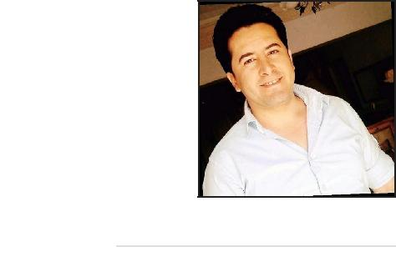

Number years of experience: 10

- Electrical Systems & Controls – Electrical Code

- Installations & Maintenance – Safety &

QA

- Electromechanical Repairs– Wiring Diagrams Blueprints &

- Schematics– Troubleshooting Generators & Transformers

- Testing Instruments Switches & Circuit Breakers

Field

- Electricity, Gas and Water

- Production, Transmission and

Distribution of Electricity

- Electricity Production

- Electricity Transmission

- Electricity Distribution.

Languages

Arabic: Mother language.

English: Good

French: Excellent

Electrical Supervisor | 2014-01 - 2015-01
Tunisia

Project: Shut Down Maintenance

Conduct loop checking and megger testing of newly installed additional and temporary cables for Electrical equipments.

Performed preventive maintenance in all Electrical Equipments.

Follow the procedure of permit to work system implemented by the company on highest standard.

Observed HSE & S rules and ISO 14001 implemented by the company.

Electrical Supervisor | 2009-12 - 2013-11
Tunisia

Shut Down Maintenance

(Offshore ASHTART Plateforme Sfax Tunisia)

Performed corrective and preventive maintenance in all ElectricalEquipments; AC/DC Motors, Transformers, Switchgears, MCC's, Slip rings, battery systems, Lighting systems and Galley area.

Ensure that all machinery system are running in normal operatingcondition, 4000 & 5000 tons Cranes, Crawler Crane, AC/DC motors for Winch systems, Generators.

To take correct reading of current and voltage and KWH during every hours in a day from feeders to log sheet book and checking battery charger.

Education

Diploma | 2007 - 2009
The Sectoral for Training of Electronic Sousse, Tunisia
Bch Automation and IT
Diploma | 2001 - 2003
CSFE Sousse Tunisia
Professionnel Technician BTP,
Automation and IT

