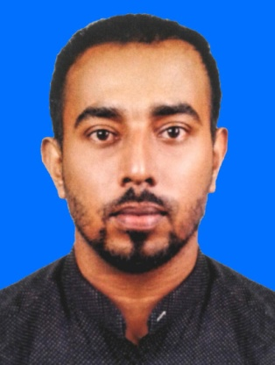
MUNEER

Email:- muneer-393886@2freemail.com

PROFESSIONALSUMMARY

Highly-qualifiedandexperiencedincustomercareseekingapositioninwhichtoutilize

knowledgeandskilsatainedintheindustryandalsoEagertoofferprofessionalserviceas

welaslearnfrom otherprofessionals.Inadditionalytodevelopthedivisionasamedical

representativeorpharmacistusingthisknowledgeandskils.

COREQUALIFICATIONS

- Capableofrecordingandgatheringrelevantinformation.

- Customerserviceskilswithafocusonmeetingtheneedsofthecustomerfirst.

- Capableofworkingindependentlyaswelaswithateamofothers.

- In-depthknowledgeofstandardsandregulationsrelatedtocustomercare.

- Organizedinalpaperworkandrecordkeeping.

- Extremeatentiontodetailinalwork.

- Proficientincomputerskilsnecessaryforkeepingrecordsandinventory.

- Contributestoteameffortbyaccomplishingrelatedresultsasneeded.

ACHIEVEMENT

- Specialtrainingcourseaboutcosmetics(welknowledgeofskinproblemsandhow thecosmeticsshoulduseformenandwomen)

- CertificateincustomercareandmarketingingooddistinctionatCBSInstituteinSri Lanka.

- Graduateinasapharmacytechniciantohandlemedicineinaproperway.

STRENGTH

- FluentinEnglishandArabicalsocandealwithArabiccustomerswel.

- Goodcomplexionandpersonalityatractionface.

EXPERIENCE

- WorkedinQatarasanassistantpharmacistabout5years.From2005-2010inoneofthebranchofLULUPharmacy.

- WorkedinSriLankaasamedicalrepresentativeabout2 yearsfrom2011-2013.

- in(InSriLanka)asamanagerforthelast4Yearssince2014

        - Handlingtheover-aloperationsofthepharmacypersonalyasitshead.

  - Keepaccurate,up-to-daterecordsandpatientprofilestoensureaccuracyand dealingchequewithbankinandout.

  - Involvingofpurchasingmedicines,evaluatesuppliersreviewproductquality andoftensupervisepurchasingagentsandselers.

  - Keepincontactwithdoctorsandhospitalsregardingpatientswhennecessary

  - Returnphonecalsinatimelyandprofessionalmanner

  - Assistandinstructcustomersinthepurchaseofnon-prescriptionmedications andmedicalequipmentwhentheyareinneedofhelp

EDUCATION

- NationalCertificateinPharmacytechnicianNVQlevel4

- Certificateofcomputersoftwareandhardware

- PassedO/LandA/Lexamingooddistinctions

- CertificateinMarketing

LANGUAGE

Fluentin | ✓ English |  | ✓ Tamil
 | ✓ Hindi |  | ✓ Malayalam
 | ✓ Arabic |  | ✓ Sinhala
PERSONALINFORMATION
 |  DATEOFBIRTH |  | :-04/06/1984
 |  SEX |  | :-Male
 |  CIVILSTATUS |  | :-Maried
 |  Nationality |  | :-SriLankan

 DrivingLicense :-SriLankanLicense

