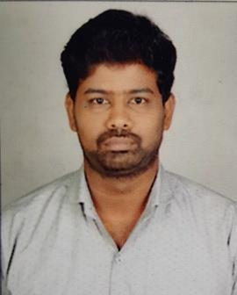

MUTHUMANI

BACKEND & COORDINATION
 @

Muthumani-393918@2freemail.com

OBJECTIVE

To be a part of an organization where my skill sets contribute in a big way to the success of the organization and which in turn helps my own career development and progression.

 | EDUCATION
 | Mechanical Engineering | MADURAI
(2012 – 2016) | SACS MAVMM ENGG COLLEGE – 68 %
H SC | MADURAI
(2010 – 2012)
M. K. H. S. S | STATE BOARD – 60 %

SS LC | MADURAI
(2008– 2010)
B. H. S. S | STATE BOARD – 62 %

WORKING PROFILE

As Backend coordinator From june-2016 (To) june-2019 -- MADURAI

IMPLANT TRAINING

- Undergone Training in "RAILNETSOFTWARE SOLUTIONS",(recognized by DOE,Govt of india )- Madurai.

- Undergone Training in "TVS TYRES"- INDIA

ROLES

- Administrative assistant
- Performs administrative office support activities for multiple tasks
- Telephone calls, receiving and directing visitors
- Worked under the Business Development Team

- Word Processing, maintain/creating data base Spreadsheets and Presentations.
- Basic IT support
- Managing communications & marketing (E-mail & SMS Marketing)
- Social media campaigning
- Multiple website maintenance
- Website maintenance and CRM maintenance

- Support sales team
- Senior event coordinator

PERSONAL STRENGTH

- Social grouping.

- Communication skill and good organizational skills.

- Easy to interact with others.

- Punctuality & patient.

- Flexibility&Reliability.

 | PERSONAL PROFILE
Date of Birth | : 13-10-1994
Sex | : Male
Nationality | : Indian
Marital status | : Single
 | Passport Details
DATE OF ISSUE | : 08.10.2015
DATE OF EXPIRY | : 07.10.2025
 | DECLARATION

I hereby declare that the information furnished above is true best of my Knowledge and I bear the responsibility for the correctness of the above-mentioned particulars.

Place:

Date: MuthuMani

