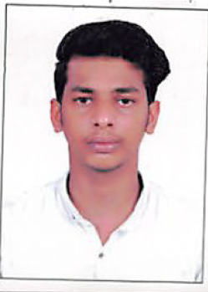
CURRICULUM VITAE

PERSONAL DETAILS
NAME : ASHIK
NATIONALITY. :INDIAN
SEX :MALE
DATE OF BIRTH :21/01/1998
  - AIL : ashik-393920@gulfjobseeker.com

OBJECTIVE

Seeking a position in a more challenging environment where my skills, experience and creativity could be productively to further a firms environmental objective

LANGUAGE KNOWN
    - ENGLISH, MALAYALAM,ARABIC,TAMIL

EDUCATIONAL QUALIFICATION
    - SSLC

    - PLUS TWO

EXPERIENCE
    - 3 YEARS WORKING AS SALES EXECUTIVE IN DUBAI

DECLARATION
I hereby confirm that all the details given by me are true to the best of my knowledge and belief.

Date :
Place: ASHIK

