CURRICULUM VITAE 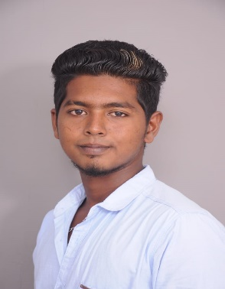

HALITHU
E-Mail : halithu-393923@gulfjobseeker.com
TARGET JOB: Office Boy

CURRENTLY ON VISIT VISA VALID TILL 28th September 2019

Career Objective:

Self-motivated, results-driven Professional with notable proficiency in user support, incident management, multitasking and teamwork while maintaining proactive responsibilities, attention to detail & continuous learning to ensure timely & effective achievement of service level objectives & business support.
Seeking to apply & further develop my skills in a technical customer support role of greater responsibility with potential for new challenges & professional development.

Academic Profile:

SSLC (SECONDARY SCHOOL CERTIFICATE) at laurel Higher Secondary School.Pattukkotai,
Tamil Nadu, India 2014 April

Work Experience:

Working as a Assistant electrician From 2014 -July -to- 2017 October.

Working as a store Assistant from March 2018 – to – June 2019

Personal Details:

Name : Halithu
Nationality : Indian
Religion : Islam
Date of Birth : 15/04/1992
Marital Status : Single
Languages Known : English, Tamil, Malayalam

Declaration

I herewith sincerely affirm that the statements and the information’s furnished above are true and correct to the best of my knowledge and belief.

Date: Yours Sincerely,

Place [Halithu]

