SURAJIT

EMAIL: [Surajit-393934@gulfjobseeker.com](mailto:Surajit-393934@gulfjobseeker.com)

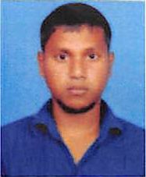

OBJECTIVE:

To explore and gain experience in various career options, as well as to become well- rounded in various job settings. To become a part of a company’s quest for success where I could render my full support and service as expected from me.

PERSONAL INFORMATION:

Date of Birth

Nationality

Gender

Languages Known

07.01.1991

India

Male

English, Hindi

PERSONAL SKILLS:

* Passionate for excellence
* Positive attitude and adaptability & Hardworking and honest
* Hardworking ambitious & innovative
* Good Communication skill

EDUCATION:

* Higher Secondary

WORK EXPERIENCE:

* Worked as Building cleaner in International City, Dubai, UAE from Sept 2018-Sept 2019
* Worked as BELLY BOY 1 year in SAUDI ARABIA from 2015-2016
* Worked as Food and Packing 1 year in India form 2014-2015

PASSPORT DETAILS:

Date of Issue Date of Expiry Visa Status

18.01.2018

17.01.2028

Employment

DECLARATION:

I do hereby declare that the above details are true and accurate to the best of my knowledge and belief.

SURAJIT

.