CURRICULUM VITAE

RIYAS
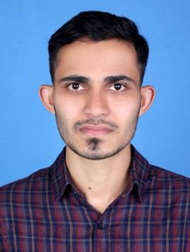

Email Id : riyas-393936@2freemail.com

Post Graduation in Business Administration Specialization Finance & HR

PROFESSIONAL OBJECTIVE

- To secure a junior level staff position with a special interest in accounting.

- To obtain an administrative position in an organization where I can use my management techniques.

SUMMARY OF EXPERIENCE

Having Two Years of experience in Accounting as an Assistant Accountant in an Indian firm. During this duration of time I have obtained sufficient experience in the method of accounting practice, and It helped me to grasp knowledge about fund allocation, and also increased my accounting accuracy, analysing Skill and work speed.

Also have the experience in account payables during the time of internship as an accountant trainee in Banglore, India. I was carrying the work of maintaining invoices of the company and the duty of recording the payment status.

ACADEMIC QUALIFICATION

Master of Business Administration (MBA) | - | 2017 | Oxford College Banglore.
Batchelor of Commerce (B.com) | - | 2015 | Govt. College Elerithatt
Pre Degree (Commerce) | - | 2012 | Govt. School
S.S.L.C (General) | - | 2010 | Govt. School

TECHNICAL SKILLS

❖ Tally ERP 9 | : | VAT/GST
❖ Operating System | : | Windows 7, Windows 8, Windows XP
❖ Offfice Packages | : | MS Office Word/ Excel, Photoshop

JOB RESPONSIBILITIES

- Prepare all accounting transactions.

- Reconcile accounts payable and receivable.

- Handle monthly, quarterly and annual closings.

- Manage balance sheets and profit/loss statements.

- Report on the company’s financial health and liquidity.

- Comply with financial policies and regulations.

PERSONAL DETAILS

Date of Birth | : | 25th May 1994
Gender | : | Male
Nationality | : | Indian
Marital status | : | Single
Visa Status | : | Visiting
Language Known | : | English, Malayalam

DECLARATION

I hereby declare that the above stated data is true and correct to the best of my knowledge and belief. If I selected to serve your esteemed organization I assure you that I will prove my abilities for entire satisfication of my superiors.

Place : Dubai

Date : RIYAS

