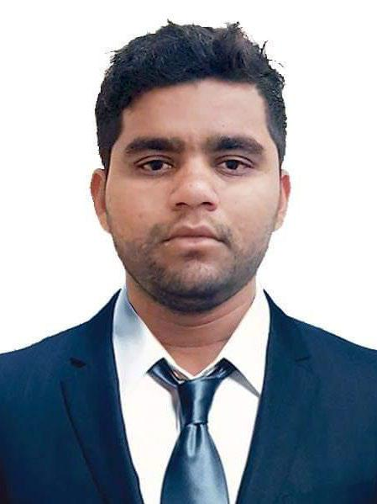
CurriculumVitea

YASER

E Mail: yaser-393939@2freemail.com

Career Objective

To work in a challenging and competitive environment where I can practically apply and improve my Managerial Accounting Skills required from my education; experienced to add value and which would provide an opportunity for Professional Growth and Realization of Organizational Goals.

KEY STRENGTHS:

Able to learn new challenging concepts; workaholic; and eager to learn new things with a capacity to perform under deadline pressures on an ongoing basis with minimum supervision. Practical with systematic approach and able to handle multiple tasks/processes with Excellent Management Oral and Written Communication, Excel as well as Interpersonal Skills.

Key Skill

- Microsoft Office

- Computer Software

- Installation OS Repair

- Ability to work under minimum supervision

- Ability to work under pressure

- Good communication skill

- Ability to learn faster

- Ability to Co – Ordinate activities

Experience Information

- (March 2016 – March 2017)

  - Bidar, India

A. CE Customer Executive

      - Performs general clerical duties to include but not limited to: photocopying, faxing, mail distribution and filing. Coordinates and maintains records for staff office space, phones, company credit cards and office keys. Creates and modifies various documents using Microsoft Office.

- ( Apr 2017 – Apr 2018 )

      - B. Logistics’ Executive

      - Sells products by establishing contact and developing relationships with prospects; recommending solutions. Maintains relationships with clients by providing support, information, and guidance; researching and recommending new opportunities; recommending profit and service improvements.

- ( May 2018 – Oct 2018 )

  - C. IT Admin In Customer Care Service

KYC Agent Work In Paytm Payments Bank India

- ( Nov 2018 – June 2019 )

D. Billing Department Coordinator

Maintain a record of total per day Collecting Amount and reporting of Billings Department Head Which Helps and responsible of management and administration for record of OPD Bills Lab Test Fee That Paid By patients for treatment our Discharge Documents for proceeding etc

Education Qualification

Bachelor of Com, General Computer |  |  |  |  |  | : | Gulbarga University Gulbarga India
PUC |  |  |  |  |  | : | Pre-University Technical Education Board Bangalore
SSLC |  |  |  |  |  | : | Karnataka Secondary Education Examination Board
Passport Information
Passport Issue Date |  |  |  | : | 12-02-2016
Passport Expiry Date |  |  |  | : | 11-02-2026
Language Known
Language |  |  |  | Reading |  | Writing |  | Speaking
Urdu |  |  |  | Excellent |  | Excellent |  | Excellent
English |  |  |  | Excellent |  | Excellent |  | Good
Hindi |  |  |  | Excellent |  | - |  | Excellent
Personal Information
Sex |  |  | : | Male
Height |  |  | : | 5.9”
Date of Birth |  |  | : | 31ST January 1991
Place of Birth |  |  | : | Bidar Karnataka, India
Nationality |  |  | : | Indian
Marital Status |  |  | : | Single

Character Reference is available upon request.

