CV
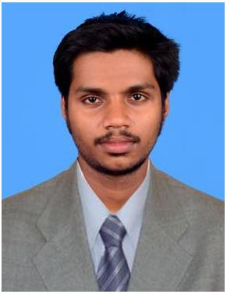

ENGG. RAHUL

Rahul-393997@2freemail.com

Current location = DUBAI

OBJECTIVE

Seeking a challenging job in an Organization/ Institute where, I can enhance my Professional skills, Knowledge and contribute to overall its success.

WORK EXPERIENCE/ INTERNSHIP’S
- CONSTRUCTION company

  - Job Duration: 2 years and 7 months (22-08-2016 to 30-04-2019)

  - Position: as a site engineer & a autocad designer.
  - Job Responsibilities:

      - Constructing commercial building and steel building.
      - Designs many plans & working drawing.

      - Managing and forecasting spend, using whole life cycle costing techniques, ensuring that work is kept to budget.

      - Follows applicable building codes and safety regulations in civil engineering.

- CONSTRUCTION company

  - Job duration: 1 Years (01-08-2015 to 30-07-2016)

  - Position: Design Engineer

  - Job Responsibilities:

    - Use computer-assisted engineering and design software and equipment to perform assignments.

    - Using specialist computer-aided design (CAD) software and other resources to design the plan required for the project.

    - Managing and forecasting spend, using whole life cycle costing techniques, ensuring that work is kept to budget.

    - Monitoring building construction and processes.

    - Follows applicable building codes and safety regulations in electrical engineering.

    - Excellent oral and written communication skills.

EDUCATION
B.E CIVIL Engineering,

CAPE INSTITUTE OF TECHNOLOGY, KANYAKUMARI .
APRIL 2015.

COMPUTER SKILLS
- Engineering Software: Revit, Auto CAD, staddpro
- Office Applications: Microsoft

Final Year Project
Road construction using geocells.

Other Projects.

- Total station.
- Theodolite surveying

Personal Information
• | Date of Birth | 23/01/1993
• | Marital Status | Single
• | Nationality | Indian

LANGUAGES
Proficiency in speaking in Malayalam, English, Hindi and Tamil.

ACTIVITIES AND INTERESTS

Driving, Newspaper reading, Searching on internet, Gardening, Computers.

REFERENCES
Available on request.

MISCELLANEOUS

Strength : Positive thinking , Hardworking , Helping nature, Self motivate.

DECLARATION

I hereby declare that the information given above is true to the best of my knowledge and belief.

Rahul

Dubai

