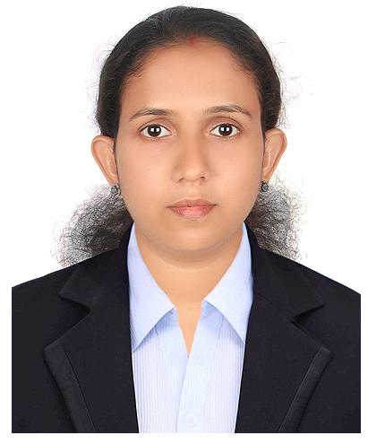

SHARIKA

SHARJAH,UAE

E-Mail: sharika-394030@2freemail.com

Profile

Objective ToworkforanorganizationwhereIcaneffectivelyusemy knowledge,skils,withatitudeofresponsibilityandconfidenceto taketheorganizationaswelasmycareertogreaterheightsand achievesuccess.

Summary | AbuddingprofessionalwithM.Com Finance.Possessanalytical
 | thinking,innovativemindandproblem solvingability. Aquick
 | learnerwithabilitytoworkunderpressureandmeetdeadlines.

ProfessionalExperience

1.Designation:Accountant

Duration :15-10-2018to04-04-2019

Organization: CHARTED

ACCOUNTANTSFIRM

Responsibilities

- Preparationoffinancials

- PreparationofReceipts&paymentsstatement

- Regular&compoundingGSTfilingsofdifferenttypesofcompanies.

- TakingGSTregistrations

- TDScomputations&filing

- Providentfund,ESIcalculations&onlinefiling

- Preparationofincometaxcomputations&filing

- RaisingofE-waybils

- Auditing&vouchingofdaybooks,cashbooks,ledgerbooks,passbooks& bils

- MaintainingaccountsofdifferenttypeofcompaniesinTaly.

- Daybookwriting.

2.Designation:AccountsExecutive&BranchAdministration Duration :22-09-2012to20-04-2015

Responsibilities

- Preparingcashbook,JournalandLedgerAccounts.
- Preparingsalaryandcommissionsstatements
- DocumentationofSalesandPurchasedetails
- PreparingMonthly&AnnualOutstandingStatement
- Managingcashpositionthroughperiodicreviewofcashflowstatement,

paymentscheduling.
- Reconciliationofbank.
- Preparationandmaintenanceoffinancialstatements&booksofaccounts
- HandlingofPetycashandmakingday-to-daypayments
- Preparationandmaintenanceofvariousfinancialstatementsasperstatute.

- Preparationofcashflowstatements.

AcademicQualification

2013 MasterofCommerce,AffiliatedtoMahatmaGandhiUniversity

2010 BachelorofCommerce,AffiliatedtoCalicutUniversity

LanguagesKnown

- English

- Malayalam

ComputerProficiency

Proficientwithavastarrayofaccountingsoftware’sandconceptsandincluding:

PostGraduatediplomaincomputerapplication.(PGDCA),Taly(ERP-9),Peachtree, QuickBooks,MSExcel,Word,PowerPoint,Expertknowledgeincomputerrelated operations,Internetoperations&E-mailhandling.

PersonalDetails

• DateofBirth | :12thMay1987
• Gender | :Female
• Nationality | :Indian
• MaritalStatus | :Maried
• VisaStatus | :HubandVisa

Declaration

Idoherebydeclarethattheabovesaiddetailsaretruetomyknowledgeandbelief.

Place:

Date: SHARIKA

