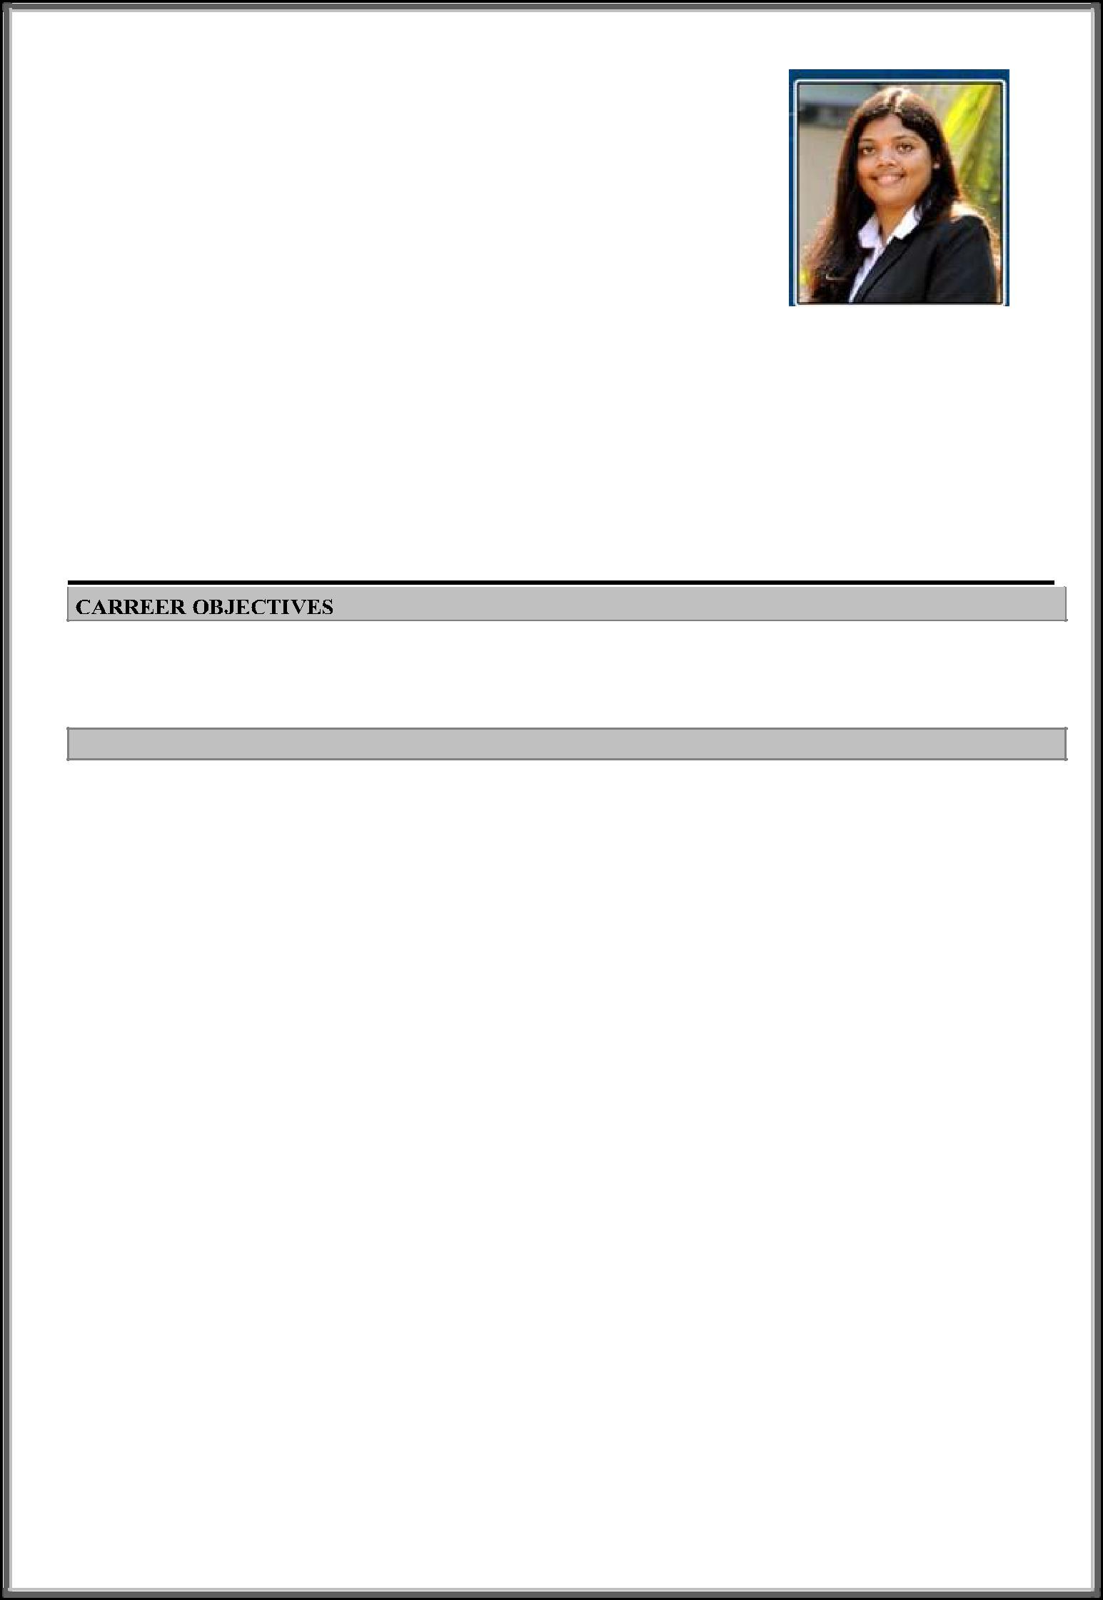

CURRICULAM VITAE

Name: Pavitra
Language Known: English, Hindi, Tulu, Marathi, Kannada

Date of Birth: 19th August 1990

E-mail Id: pavitra-394037@2freemail.com

Visa status: Personnel Sponsored Visa.

Current Location- Al Karama , Dubai

Notice Period: Immediate

To seek a position in a progressive organization that offers innovative and challenging working environment and that will nurture my skills and competencies to achieve the desired corporate and personal goals

WORK EXPERIENCE

1. Joseph Group- May 2018 – Present

Export Executive

Dubai, United Arab Emirates

- Handling long term export projects for African region 
- Plan and Coordinate with client and internal team for project execution 

- Co-ordination with design dept to get the design and preparation of shop drawing & artwork. 
- Consolidation of all documents and finalizing the artwork by taking client approval. 

- Reviewing all documents related to project and forwarding this to the production BOQ for execution and Co-coordinating for inspection 

- Follow up with production on status and progress of work. 

- Obtain all legal documents necessary for exports during shipment from shipper and managing all online certification require for shipment. 
- Preparing quotation & Proforma Invoice, Packing list and send it to client 
- Work closely with production teams to provide solutions for client requirements. 

- Approval of quotation from client & release of PO 

- Acceptance of PO and maintaining document control. 
- Keeping track of projects & maintaining reports for all bill of quantity, elements addition in artwork 

- Obtains all attested legal documents necessary for exports. 
- Working on SAP to prepare Sales Order & Job Card for internal system.Prepare daily tracking report for both internal team and client 
- Working on internal Software (Designed for this project) for finalizing the project from preparing artwork to dispatch of elements. 

- Coordinating & following up with client for payment and closing the accounts in our system. 
- Managing social media marketing campaigns and day-to-day activities for company website 
- Writing content and topics to reach the company's target customers through social media platform. 
- Create and manage all published content images, video and jobs done for clients. 

- Showcasing projects done for all the industry we serve to get more leads and sales for the company 
- Writing Meta title and description for web page to maximize the traffic to site.
 

2. July 2016- October 2017 Manager- Inside Sales Lead

Mumbai

- Managing virtually by phone, electronically or social media, meetings a set of assigned or acquired accounts 

- Builds, maintains and forecasts sales pipeline, creates and develops account plans 

- Ensure effective B2B prospecting, up/cross selling of range of products. 

- Generate and qualify leads to create new sales opportunities to closure 
- Prepare monthly, quarterly & annual sales forecasts. Setting & tracking sales targets for team. 

- Sets and executes sales strategy for assigned portion of account, territory or industry vertical. 

- Build a solid inside sales that exceeds sales goals, monitor employee’s productivity & motivate team to reach daily sales goals. Make proposals on work processes. 
- Participate in client interactions to ensure cross training, customer satisfaction & management involvement regularly to maintain client relationship 

- Collaborate with marketing support & internal systems, product management & account management to facilitate new programs, campaigns & offerings 
- Manage performance via Salesforce & oversee resource planning, reporting, territories, incentives & communications for the assigned team. 

- Office Products - July 2014 - July 2016.
Business Development Manager

- Responsible for new business development & performance of marketing activities through B2B Channel and retaining existing customers. To convey staples value proposition to clients 
- To develop, implement and transform the company’s overall business strategy, motivate the team, consolidate existing business and seek out new avenues for business so as to maximize the profits. 
- Following up with the clients and negotiating the deals. 
- Perform full sales function, including pre-sales activities, preparing quotations and responding to tenders, presentations, contract negotiation, gathering market intelligence as well as handling post-sales activities. 
- Work closely with pre-sales & delivery teams to provide solutions for client requirements. 
- Manage and maintain key relationships with vendors and collaborating partners 

- July 2011-Aug 2012
Credit Billing (CB) Analyst-Mumbai

INTERNSHIP

 

- SCMC Pvt Ltd Jan 2014 – March 2014

- IMRB International May - July 2013
 

EDUCATIONAL QUALIFICATION

Year of | University / Boards | Institution | Result
Passing | Exam Passed
 |  | Fr C Rodrigues Institute Of Management Studies
2014 | MBA- (Marketing) | (Fr Agnels Business School), Mumbai University | Pass
2011 | B. Com | SIES College of Commerce | Pass
 

SKILLS
➢ Thorough knowledge of Windows XP, MS Office, Salesforce Software, SAP 
 

 

 

