Jun 2018 – July 2019 Ajman, UAE
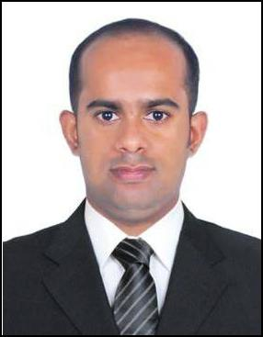
LIBIN

Email – libin-394050@2freemail.com

Professional Summary

Recently i was working for Cognito Management Consultancy as an accountant located in Ajman, UAE. Before

relocating to UAE, was functioning as Senior Accountant in Kumarakom Cuisine Pvt Ltd, Chennai. I started my

carrier in accounts from Param Prasad Charitable Society's educational institutions named as “Mary Matha High

School & Jr. College and Mary Matha English Medium School”, Maharashtra, India.

Skills

• Data entry | • Tally erp
• Accounts payable and receivable | • MIS reporting
• Office administration | • Bank reconciliation
• Book keeping | • Time management
• Invoice preparation | • MS office
• VAT return preparation & filing
• Banking transactions

Work History

Accountant cum audit assistant

Management Consultancy

- Book keeping of multiple companies.
- Assist auditors in statutory auditing schedules.

- Assigned client visit on weekly/monthly basis.

- Internal audit of schools.

- UAE VAT returns preparation and filing.

- Supervision and review of financial accounting records.

- Prepares asset, liability, and capital account entries by compiling and analyzing account information.

- Secures financial information by completing data base backup.

- Reconciles financial discrepancies by collecting and analyzing count information.

- Answers accounting procedure questions by researching and interpreting accounting policy and regulations.

- Preparation of bank reconciliation statements.

Senior Accountant Jul 2017 - Apr 2018

Chennai, Tamilnadu, India

- Managed accounts payable as per the terms of Company policies.

- Maintained GST Reports as per the provisions of respective law.

- MIS reports prepared in relation to weekly and monthly sale, Stocks in store.

- Prepared payroll of 100+ staffs and salary transfer in timely manner.

- Liaising with third parties (Swiggy /Zomato /Uber eats) in relation to payments and other compliance.

- Petty cash handling of 4 branches.

- Purchase order processing and its followup till delivering in store.

- All kind of banking transactions handling.(CDC/PDC Cheque, Online money transfer, Statutory payments…etc)

Accountant | Jun 2014 - Feb 2017
Educational Institutions
-Mary Matha High school & Jr college
-Mary Matha English Medium School. | Pune, Maharashtra, India

- Prepaid reports on monthly basis relating to outstanding fee and its submission to management.

- Maintained continuous view and monitoring over the multiple bank accounts and reconciled it with school data basis with no time lag.

- Handled around 160+ staff's salary, pf ..etc

- Controlled over 40+ school buses as per the rules and regulations.

- Closed and forwarded accounts info to auditors on monthly basis according to the prevailing accounting standards for auditing purpose.

- Office administration.

- PDC /CDC cheque management and statutory payments.

- Customer management.

Education

Bachelor of Commerce: Finance And Taxation 2014

M G University, Kottayam. Kottayam, Kerala

Personal Profile

Date of Birth : 21 October 1991

Nationality : Indian

Gender : Male

Marital Status : Single

Languages Known : English, Malayalam, Hindi

Religion : Christian

Availability to join : Immediately

I solemnly declare that all the information furnished above are true and correct to the best of my knowledge and belief.

LIBIN

