Nogdalla
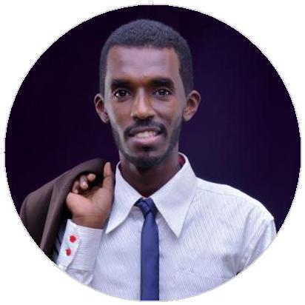

Electrical Power Engineer .

I graduated first in my class with Bachelor of Science (Honor) in Electrical Engineering (Power) with CGPA 3.47 out of 4.00 then I got the acceptance (Admission) to Study Master of Science in Electrical power engineering in Chalmers University of Technology (University in Gothenburg, Sweden, Ranked 82th in Engineering and Technology in the world (According to THE Ranks 2019) ). I have more than three years experiences in supervising electrical and mechanical workshops at Al-wahashab Transport Company Ltd, and diploma in computer science at British educational institutes and Diﬀerent training certificates.

WORK EXPERIENCE

Workshop supervisor

01/2011 – Present Khartoum , Sudan .

Part-Time .

Achievements/Tasks

Leading and supervising the mainatence periods in the workshop.

Following the performance and the work of the technicians in the workshop.

Writing reports explaining the performance of the work in workshop and clarify the requirement to improve the workshop.

Planning and organising the maintenance period in the workshop.

Workshop supervisor

10/2012 – 12/2014 Khartoum , Sudan .

Full-Time .

Achievements/Tasks

Leading and supervising the maintenance periods in the workshop.

Following the performance and the work of the technicians in the workshop.

Organising staﬀ training and students internship periods.

EDUCATION

Bachelor of Science (Honor) in Electrical Engineering (Power).
ALMughtaribeen University

12/2014 – 12/2018 | Sudan-Khartoum-jabra, Main Street,
 | Square 19.

Diploma in computer science British educational institutes

08/2010 – 08/2010 Sudan , Khartoum .

Nogdalla-394078@2freemail.com

Date of Birth:- 15/04/1993

SKILLS

Teamwork. Self-motivation.

Leadership and supervising skills

ACHIEVEMENTS

The Acceptance to Study Master of Science in Electrical power engineering in Chalmers University of Technology. (04/2019 – Present)

University in Gothenburg, Sweden, Ranked 82th in the world (THE)

Academic Leader at AlMughtaribeen University (12/2016 – 09/2017)

Also I was a board member and Volunteer at The electrical engineering Society at AlMughtaribeen University.

INTERNSHIPS

Khartoum refinery company Ltd

Two weeks , 8 hours per day (12/11/2017 To 23/11/2017).

Kenana sugar company

One week and one day , 8 hours per day (22/12/2016 To 29/12/2016).

Sudanese electricity distribution company Ltd

Two weeks , 8 hours per day (14/11/2016 To 27/11/2016).

AL-WAHSHAB Transport Company Ltd

Seven months , 9 hours per day ( 01/04/2010 To 01/11/2010 )

LANGUAGES

ENGLISH

Arabic

