SAAD

Maintenance Engineer

Saad-394085@gulfjobseeker.com

Dubai

UAE

TECHNICAL SKILLS

Assessing project requirements Measuring the performance of mechanical

Agreeing budgets, timescales and specifications with clients and managers

Providing technical advice

Testing, evaluating, modifying and re-testing products

Using computer-aided design/modelling software

INTERESTS

Reading & Searching for new Techniques

REFERENCE

Available when request - ""

 EXPERIENCE

( Kamara)

Maintenance Engineer

2017 - Present

- Charged for (Cake & Cupcakes & chocolate & Biscuits) Prodution lines.

- Packaging machines maintaince.

- Pumps & Boilers maintenance.

- Double twist (wrapping machines) maintenance.

- Weighers maintenance.

- Perform Day-to-day technical tests.

Trade and Industry

Technical Office Engineer

June 2016 - January 2017

-Designer for CNC, Punch, Laser cut Machinery

- Describe programmable instrumentation that uses letters, numbers and symbols to automate machine operating processes.
- Responsible for the programming, maintaining, repairing and testing of these machines so that they can effectively carry out the functions necessary for a given enterprise.

Armed forces

First lieutenant

April 2014 - April 2016

- Monitor long term maintenance programs and make sure that mandatory items are included to ensure that vehicles operate normally and that no items are omitted.
- Responsible for ensuring that vehicle maintenance is performed at the right time.
- Provide information needed to direct specific vehicles to maintenance and repair shop as scheduled.
- Sure that planned maintenance work is followed requirements in the future.

TRAINING

Toshiba (Manufacturing of Electrical Motors).

Egypt Air ( Maintaince of pneumatic Systems).

PROJECTS

Skyscrapers Glass Washing Robot

A robot for cleaning the glass of skyscrapers front. (resbonsible for design and calculations of the project)

PERSONAL STRENGTHS

Work under pressure

Time Management

High Motivated

CAREER OBJECTIVE

An inspired Mechanical Engineer with +5 years experience who is willing to gain more knowledge and new skills A strong believer that ambition along with planning, great effort and effective teamwork are capable of changing the world.

Design a ventilation system
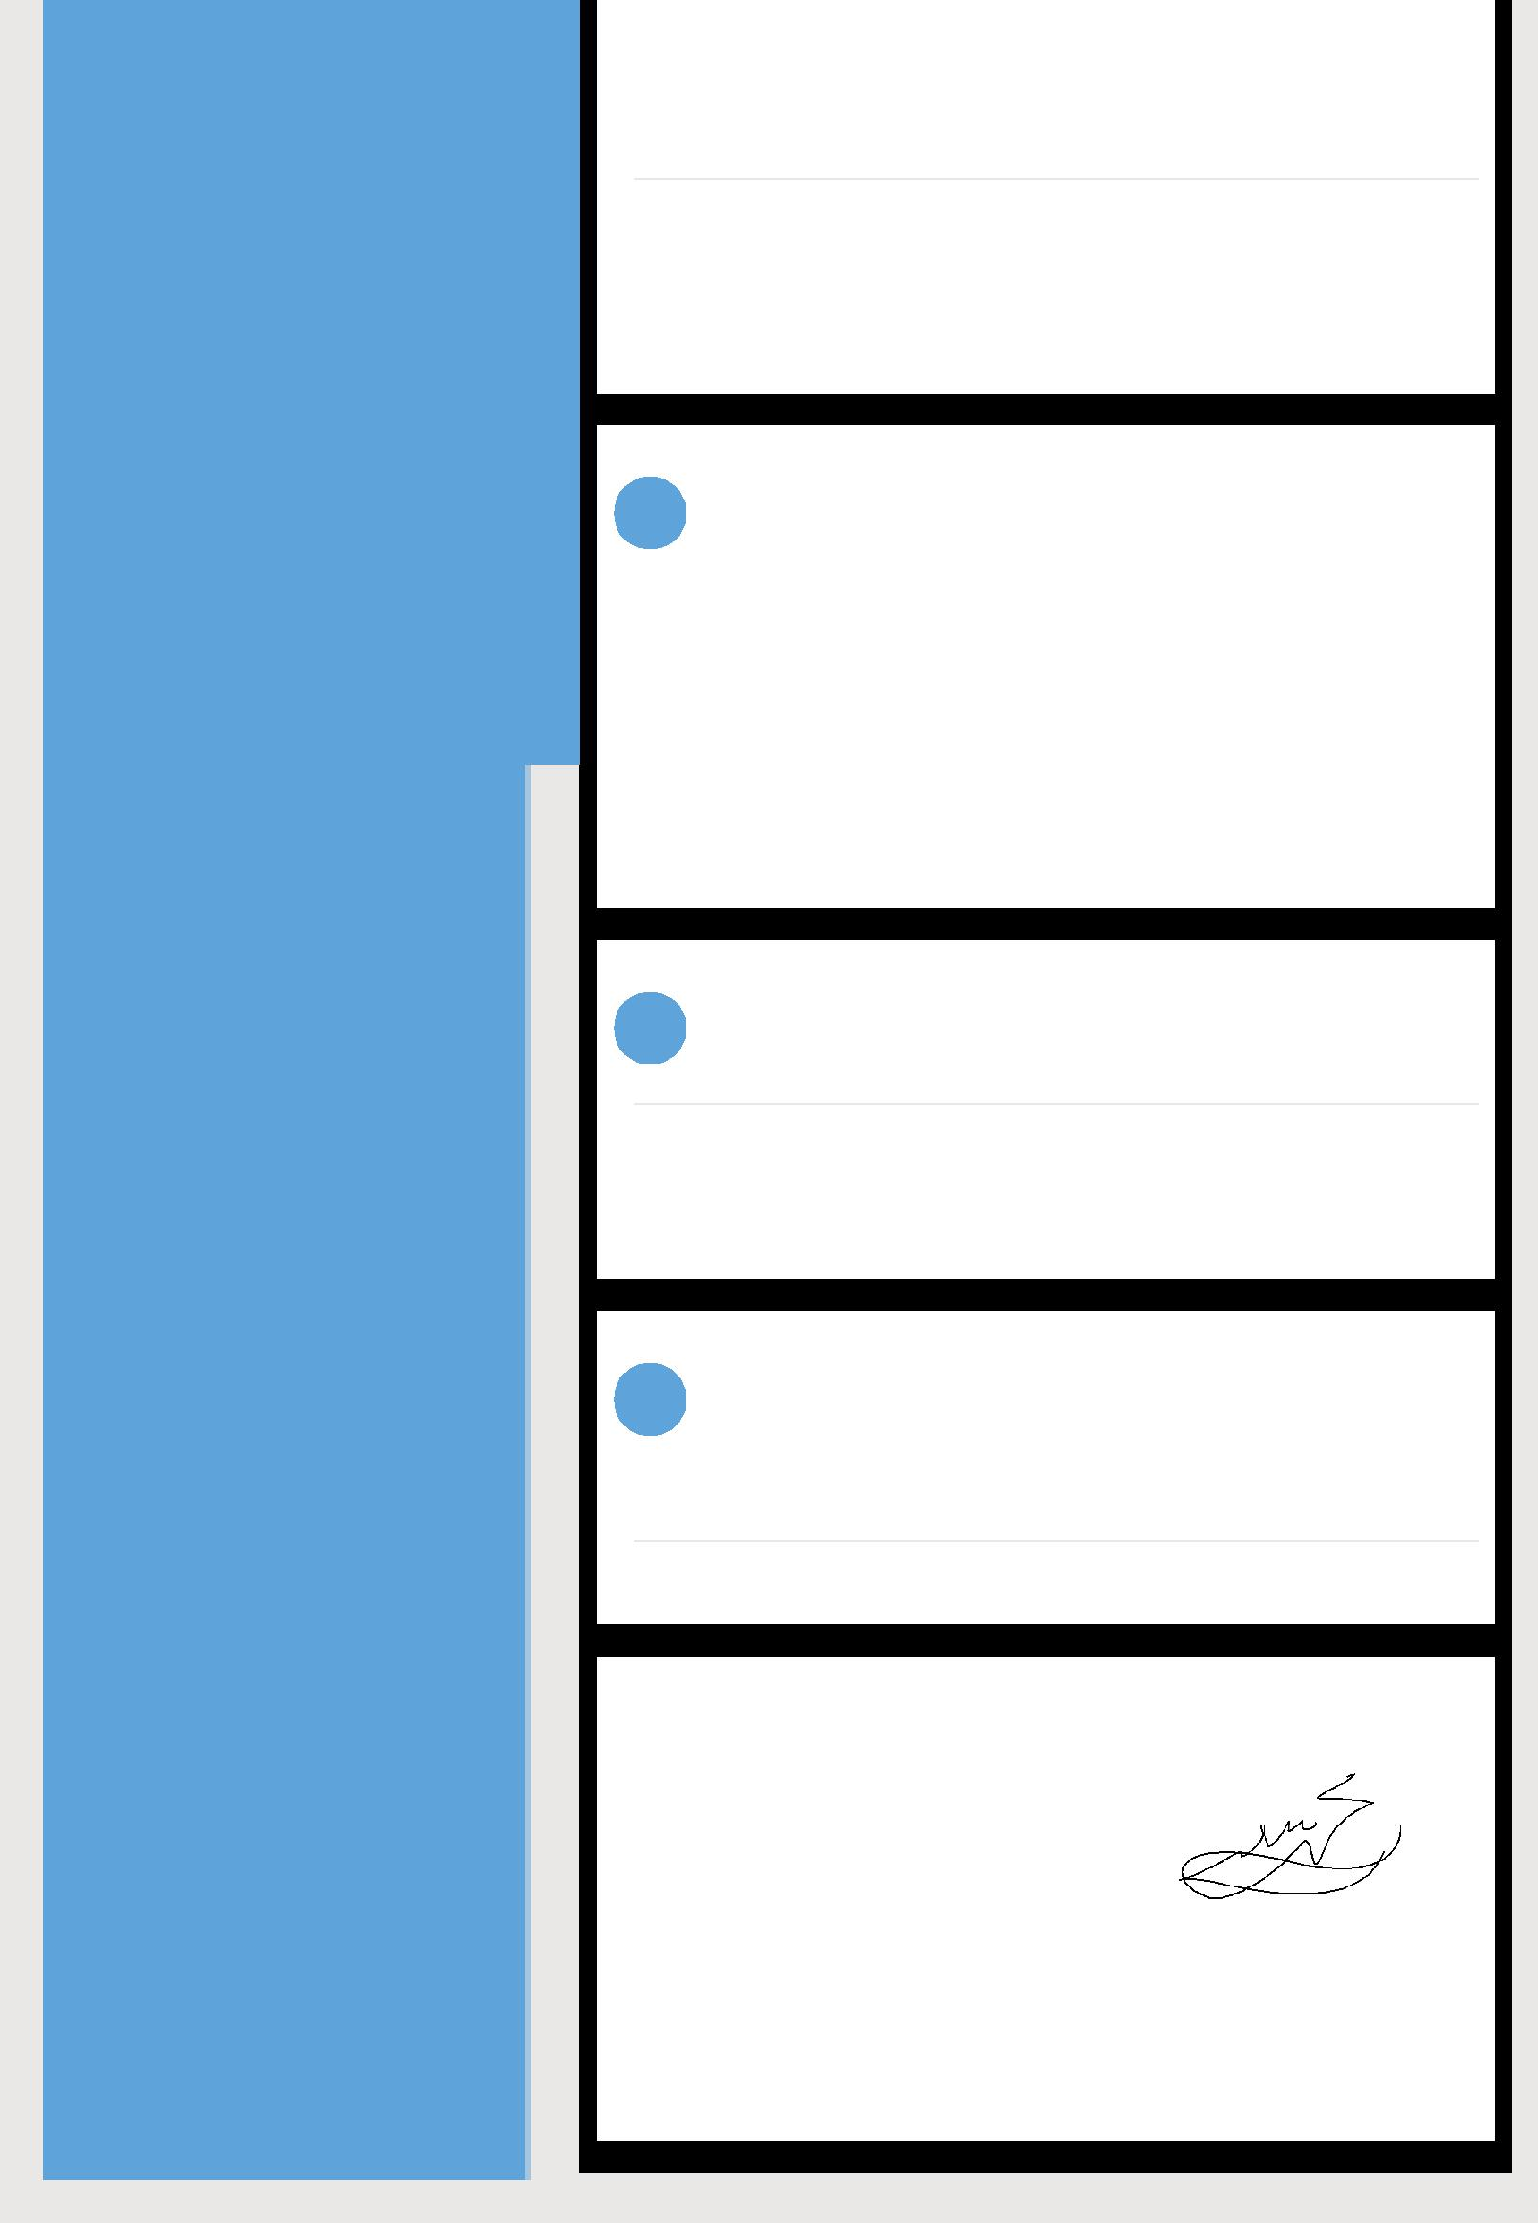

(Designed a ventilation system for a kitchen of a hotel to exhaust smoke and heat and intake a fresh air)

Agricultural Robot

- An agricultural robot to facilitate the agriculture process, responsible for the programming of this robot).

PERSONAL PROFILE

Date of Birth | : 3/12/1989
Marital Status : Married
Nationality | : Egyptian
Hobby | : Reading Searching New Techniques Traveling

EDUCATION

Benha University

Bachelor of Mechanical Engineering

2012

 LANGUAGE

Arabic ( Mother Tongue)

English ( Excellent)

SAAD

