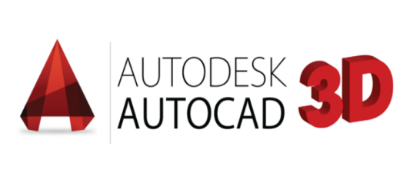
GOVINDAN
JOBS TITLE : Autocad Draftsman
Email: govindan-394100@2freemail.com

OBJECTIVE
Seeking a challenging opportunity in your esteemed organization to prove my skills. I expect a challenging, responsible career in which I can put all my efficiencies to the company as well as mine.
EDUCATIONAL QUALIFICATION:
DEGREE : Bachelor of mechanical Engineering
YEAR OF COMPLETION : July 2015
INSTITUTION : Annamalai University, Chidambaram, India
PERCENTAGE : 64 %
HSC : Govt higher sec school tamilnadu STATE BOARD 2011
PERCENTAGE : 58 %
S.S.L.C : Govt higher sec school tamilnadu STATE BOARD 2009
PERCENTAGE : 58 %

ADDITIONAL QUALIFICATION:
Diploma in welding engineering and technology
Diploma in product design

SOFTWARES KNOWN:
AutoCAD 2D&3D,Architecture draftsman
REVIT architecture BIM
Solid Work ,MS Office
WORK EXPERIENCE:
Designation :Software Trainer
Duration :Aug’16 to jun’19
Location :Tamil nadu, india

WORK EXPERIENCE:
Designation : Quality checking
Duration : Jul’15 to jul’16
Location : Tamil nadu, india

JOB RESPONSIBILITY:
1. Designed and prepared plans using computer-aided design and drafting (CADD) software.
2. Calculate dimensions and allowances with accurate precision.
3. mechanical/civil drawing preparation based on client requirement.
4. Revit architecture planning draw.
5. Responding to customer’s quires regarding drawings.
6. Telecommunication based Tower Construction Layout plan drawing in Auto Cad.
7. Building layout plan, Elevation, Foundation Drawing in Auto Cad 2d & 3d.
8. Maintaining all documents and drawings as per ISO 9001:2000.

PERSONAL DETAILS:
Date of Birth : 11-12-1991
Marital Status : unmarried
Nationality : Indian
Language known : English, Tamil & Malayalam
Visit status : visit visa (till 11october)

Declaration
I hereby declare that all the information furnishes above is true to the best of my knowledge
And belief.
Signature
Place: Dubai (GOVINDAN)

