Reda

Objective
Challenging position in a reputable company where my qualiﬁcations and skills can be applied and developed .
Experienced, professional and team work environment Career development
Stability

_{Personal} _{Data} Personal Skills
Ability to learn very quickly

Abu Dhabi

Reda-394101@2freemail.com
30 March 1993
Nationality : Egyptian Gender : Male Marital status : Single
Military service : Completed
Visa Statue : Resident

Languages
Arabic English
Very hard working
Ability to work under pressure
Very well organized and independent
Very good communication and presentation skill
Can work individually and as an effective member in teamwork

Courses
Prepare accountants from Mansoura University ( 2017) Training ICDL Modules from TDNS group
The Ministry of Education Ahram technology of information General English – Level (1) to level (12)

Professional Experience
( 10 / 2017 : tillnow)
Working as a cashier in UAE
( 06 / 2016 : 07 / 2017 )
Accountant in EGYPT

Computer Skills Education

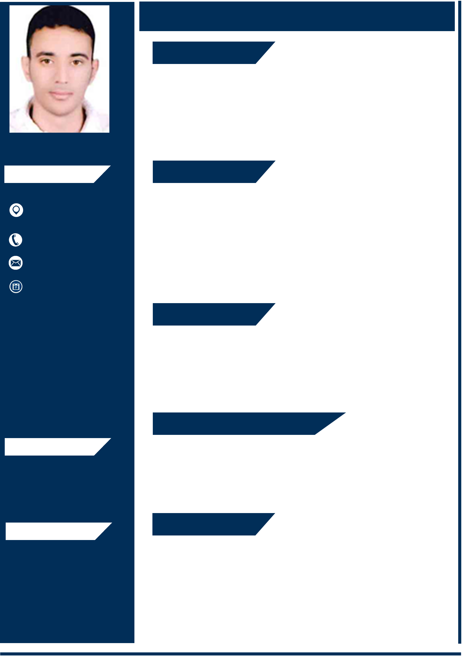Microsoft Ofﬁce Windows and Internet
( 09 / 2011 : 06 / 2016 )
Bachelor’s Degree, Accounting and Finance
Faculty Of Commerce - Azhar University English Section : Grade very good (80.9 )

