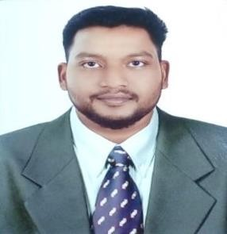
SREENADH

Email: sreenadh-394107@2freemail.com

CAREER OBJECTIVE:
A resourceful civil engineer qualified with bachelors degree who is having 3 years of UAE experience in structural, estimation and construction field. I am very confident in my skill and dedication to handle the projects within the time limits using my professional knowledge and skills I have earned from my experiences and proper schedule.

ACADAMIC QUALIFICATIONS:

COURSES | UNIVERSITY/INSTITUTE
BE.CIVIL | Shree Venkateshwara Hi-tech Engineering College, Erode, Tamilnadu.
HIGHER  SECONDARY | Board of Higher Secondary, Kerala.
SSLC | General Educational Department, Kerala.

TECHNICAL SKILLS:
- Primavera T3 (Project Manager).
- AutoCAD (2000, 2010 & 2012).
- STAAD Pro (Structural Modeling and Analysis).
- Autodesk Revit Architecture.
- Basic of AutoLISP
- MS Office, Windows 7, 8 & XP.
- Internet ability.

PERSONAL SKILLS:
- Ability to understand and present others point of view.
- Ability to understand and explaining drawings.
- Proven motivational and leadership skills.
- Creative and innovative, with good design skills.
- A team player with enthusiastic attitude

AREA OF INTEREST:
- Project managing and scheduling
- Project planning and estimation
- Project cordination
- Designing of structures

WORKS EXPERIENCES:
- Worked as site engineer from May 2014 to December 2016 in Kerala India.
- Working as project engineer and PRO in FUJAIRAH, UAE from February 2016 to till now.

PROJECTS HANDLED:
- Supervision of housing projects in India.
- Planning, estimating, scheduling and managing of works of G+1 villa projects.

PERSONAL DETAILS:

Name | Sreenadh
Date of Birth | 03/04/1992
Nationality | Indian
Sex | male
Marital status | Single.
Languages Known | English, Malayalam, Hindi, Tamil and Arabic (50%)

DECLARATION:
I confirm that the information given above are true and complete to the best of my knowledge and belief.

Yours sincerely

Place: Fujairah (Sreenadh)

