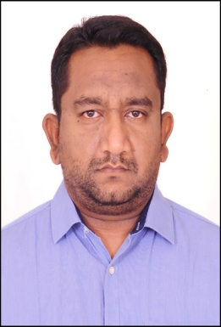
Prabhu

Email : prabhu-394108@2freemail.com

OBJECTIVE

An enthusiastic professional with drive, determination and proven ability to ensure that operations are efficient and profitable. Extensive knowledge of the industry, its working practices, recruitment, conditions of employment and diversity issues. Now looking for a new challenging position, one which will make best use of my existing skills and experience.

EDUCATION DETAILS

Course | Board/University | School/College | Result | Year of Passing
Graduate Diploma IT | University of Ballarat,Australia | IIBIT | A+ | 2009
Intermediate | Board of Intermediate ,Andhra Pradesh | Aditya Junior College | 72% | 2002
SSC | Secondary school Education | Vishwa Shanti High School | 66% | 2000

EXPERIENCE DETAILS

Designation | Duriation
Operations Manager | Mar 2015 – Aug 2019
Operations Manager | Jun 2014- Feb 2015
Site Supervisor | Jan 2012 - May 2014
Asst.Manager | Dec 2008 - Mar 2011

PERSONAL INFORMATION

Name : Prabhu

Gender : Male

Date of Birth : 14 March 1985

Languages Known: English,Hindi,Telugu

I hereby declare that the above written particulars are true to the best of my knowledge and Belief.

Place:Dubai. Yours’s Sincerely

Date:( Prabhu)

