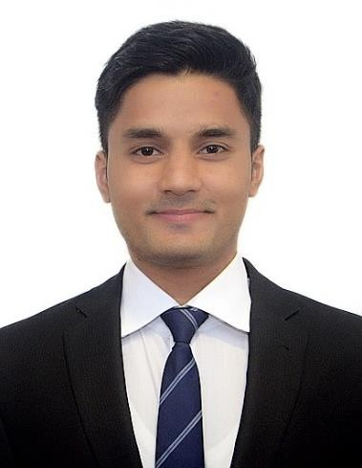
Name - GAURAV
Date of birth – 2nd June 1994 (25 yrs)
Email Id – gaurav-394119@2freemail.com

Career Objective :
Positions Interested In

To perform and improvise best engineering practices by including efficient and effective systems and processes. To increase profitability and efficiency by implementing good effective management techniques and skills.
- Execution Engineer
- Project Coordinator
- Planning Engineer
- Project Controls and Billing
Engineer

Work Experience :

May/2018 – Still Working (1.5 yrs.) Project Execution & Planning –DUBAI Responsibilities:
Language
- Project execution and controls management.
- Planning & scheduling. Updating Primavera P6 programme.
- Sub-contractor & vendor management.
- English
- Hindi
- Marathi
- Gujarathi
- MIS & monthly/weekly report.
- Fit-out works controls and management.
- Structural and finishes works management.
- Quality Assurance.
April/2017 – June/2017 (3 months)
Summer Intern – INDIA
Address
Responsibilities:
- Site execution and surveying.
Dubai – Bur Dubai, Dubai , UAE.
- Material testing and quality assurance.
- Planning and billing.
- Plant and machinery.

Achievement

- Employee of the month in Sobha LLC Dubai.
- Merit Scholarship in NICMAR.
- General Secretary in NICMAR.

Skills

- Microsoft Office – Word, Excel, Powerpoint, Outlook.
- Primavera P6 , Microsoft Office.
- Good presentation and communication skills.
- AutoCad.

