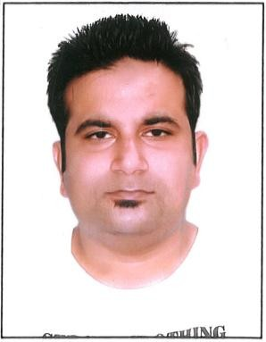
CURRICULLUM - VITAE
WAMIQ

Email ID: wamiq-394126@2freemail.com

OBJECTIVE
Seeking a career-oriented position with progressive organization where my professional experience will enable to make a significant contribution towards company’s goal.

PERSONAL DETAILS
- Name : WAMIQ
- Date of Birth : 22-09-1986
- Gender : Male
- Nationality : Indian
- Religion : Muslim
- Marital Status : Married
- Languages : Arabic,English,& Urdu

ACADEMIC QUALIFICATION
- Passed B.S.C from LUCKNOW UNIVERSITY, in the year 2009.
- Passed Intermediate from U.P BOARD, in the year 2005.
- Passed HIGH SCHOOL from U.P.BOARD in the year 2003.

COMPUTER SKILL

  - Completed One Year Diploma In Computer Application

WORKING EXPERIENCE
- Over 3 years’ Experience in ACCOUNTANT CUM CASHIER in Saudi Arabia .

- Worked in Riyadh as a “STORE SUPERVISOR” from 2 YEARS
- Working as a SALES SUPERVISOR from 4 YEARS. PASSPORT DETAILS
- Date of Issue : 08/07/2013
- Date of Expiry : 07/07/2023
- Visa Type : Visit Visa (3 Months 19 Oct, 2019)

- Cont...2

NATURE OF JOB

- Documents financial transactions by entering account information
- Recommends financial actions by analyzing accounting options
- Maintains accounting controls by preparing and recommending policies and procedures
- Prepares payments by verifying documentation, and requesting disbursements
- Maintains customer confidence and protects operations by keeping financial information confidential
- Operating scanners, scales, cash registers, and other electronics.
- Balancing the cash register and generating reports for credit and debit sales.
- Collecting payments whether in cash or credit
- Resolve customer complaints, guide them and provide relevant information
- gaining a clear understanding of customers' businesses and requirements;
- making accurate, rapid cost calculations and providing customers with quotations;
- feeding future buying trends back to employers;
- attending team meeting and sharing best practice with colleagues.

DECLARATION

Hope you will consider my C.V and give me opportunity to face interview. I shall prove my worthiness and capability.

Thanking You,

Date: Signature

Place: (WAMIQ)

