CURRICULAM VITAE

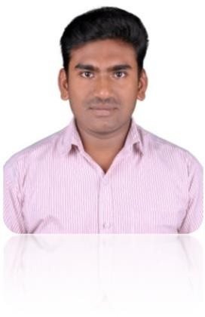
FAYIS

Contact Details:
E-mail Id : fayis-394151@2freemail.com
Visa status: Visit visa

CAREER OBJECTIVES:
To learn and grow at professional as well as personal level thereby directing my future endeavors as an asset to the organization.

WORK EXPERIENCE:

tours and travels , Calicut
Ticketing executive
January 2019 to March 2019
GDS reservation system and online reservation system
- tours and travels Ticketing executive February 2018 to July 2018
Planning and implementing travel itinerary

Tours and Travels, Cochin
Ticketing executive trainee September 2017 to January 2018
Training for airline reservation system and travel itinerary planning Customer service

EDUCATIONAL QUALIFICATION:
Course Institution Year
Bsc Computer Science | Mahatma Gandhi University | 2016
Plus Two | Kerala state examination board | 2013
SSLC | Kerala state examination board | 2011
ADDITIONAL QUALIFICATION:

Fundamentals of digital marketing | Google garage online course | 2019
Diploma in Foundation Travel & Tourism(IATA / UFTAA) | IATA accredited training center ( Alhind Academy, Calicut) | 2017

TECHNICAL SKILLS:

- MS-Office.
- Galileo reservation system
- Amadeus reservation system
- Online reservation system
- Computer hardware and software installation
- System support and administration
- Basic graphic designing and web designing
- Social media marketing
- Basics of digital marketing
- Basics of networking

PERSONAL DETAILS:

Sex : Male
Nationality : Indian
Religion : Islam
Marital Status : Single Date of Birth : 13-03-1996

LANGUAGES KNOWN:
- English
- Malayalam
- Hindi
- Tamil

DECLARATION:
I hereby declare that above information given by me on true the best of my knowledge and belief I am in possession of original certificate and I will produce it same on demand.

Sincerely,

FAYIS

