KARIM

Education

2009

2018

2018

2019

2019

2019
Email: karim-394152@2freemail.com

Bachelor of Science in Civil Engineering (Structure Sector)
Tanta University – Egypt
Very good with honor degree

Conflict Resolution and Negotiation Skills
The American University in Cairo (AUC)– Egypt

Environment and Society
The American University in Cairo (AUC)– Egypt

Critical Thinking and Writing for Engineers
The American University in Cairo (AUC)– Egypt

Sustainable Community Development
The American University in Cairo (AUC)– Egypt

Project Management Professional (PMP)
Project Management Institute (PMI)- USA

Certifications and Professional Affiliation

2009 | The Syndicate of Engineers, Egypt  Membership No. 3900448/14
2018 | FE-Fundamental Engineering (Structure)
2019 | The National Council of Examiners for Engineering and Surveying (NCEES) –USA  Project Management Professional
2019 | PMP ® NO: 2595885  Engineer In Training (EIT), Texas Board-USA
Software Capabilities
CSI SAP 2000 – CSI ETABS – CSI SAFE AutoCAD – REVIT STRUCTURE
PROKON – Adapt Builder

Responsibilities and Roles

Structural Engineer
2009 – 2012

Senior Str. Engineer
2012 – 2018
- Conduct structural analysis and design of concrete and steel structures, along with the creation of justifying structural calculations.
- Submit and review structural design deliverable with local authorities to seek approvals/permits in coordination with design Project Managers.
- Submit structural design deliverable to local clients and discuss and review deliverable to obtain client comments/approvals.
- Design structural steel, reinforced concrete, masonry, wood and glass structure.
- Familiar with international and national codes for design and construction: ACI, BS, ASCE, AISC and ECP.
- Perform all aspects of structural design associated with engineering projects.

- Provide structural design, analysis, drawing production and construction administration services for a wide variety of building types.
- Make technical assumptions, think independently to complete assigned work, and draw conclusions based on engineering judgment.
- Working knowledge of US building codes and structural design standards.
- Support preparation of design drawings, plans, sections, details, and schedule.
- Monitor and report to the Manager - Structural Design the progress of ongoing structural design and technical support activities.
- Relay client and authority comments on structural design deliverable to design Project Managers and design teams and track resolution and incorporation of comments and issues.
- Coordinate structural design on multi discipline project teams including Mechanical, Electrical, and Piping/Plumbing (MEP) professionals.
- Respond to RFI’s and review shop drawing.
- Visit construction site, supervision and meetings.
- Work with team to prepare engineering reports and details on existing and proposed facilities including towers, water tanks, rooftops, billboards and other supporting structures using applicable building and design codes.
- Work within a team oriented environment to successfully complete projects within established budgets and deadlines.
- Conduct site visits to gather existing conditions data.
- Support Project Managers in addressing tender queries submitted by contractors during the tendering phase.
- Support Project Managers in evaluating contractor bid submissions during the tendering phase.
- Integral member of a collaborative design process with Architects, Engineers and Construction professionals in an integrated work environment.

Assistant Project Manager
2018 – Present • Support Supervision Project Managers in coordinating with local authorities to obtain necessary permits and approvals to commence the construction stage, as needed.
  - Support the design and construction of a variety of new and renovations to existing industrial, manufacturing, and office facilities.
  - Involvement in projects from inception through construction under various project delivery methods.
  - Research and implementation of new technologies, systems and materials in award winning projects.
  - Project administrative functions including managing, writing, and identifying submittals, RFI's,
  - RFI's correspondence and to minimize exposure and risk in the project.
  - Ensure that construction meeting minutes are recorded and cataloged correctly.
  - Be able to read and put proposals together.
  - Able to read and comprehend drawings and plans.
  - Work with the project manager and superintendent with schedule updates.
  - Maintain and update project schedule by monitoring project progress; coordinating activities; resolving problems.
  - Process Purchase Orders and Sub-Contractor Agreements
  - Coordinate material deliveries.
  - Communicate effectively with the sub-contractors and vendors.
  - Ensure project documents are properly tracked.
  - Process Material/Sub-Contractor Buyout.
  - Interface with the Owner on all projects assigned.
  - Assemble and maintain complete project records and close-out documents.
  - Work with the Project Manager to perform project punch-list inspection(s), in coordination with superintendent and the Owner’s Representative, and issue punch list to all relevant subcontractors.
  - Manage the submittal process.

Present Occupation
Assistant Project Manager – a specialized consulting firm founded in 1998 and provides engineering services related to the following disciplines:
- Reinforced Concrete Design
- Pre-stressed Concrete Design
- Steel Structures
- Masonry Structures
- Rehabilitation of Structures
- Water Structures (Tanks, water and waste water treatment plants).

Work Experience

2015 – Till Now

2017 – Till Now

2016 – 2017

New Cairo, Egypt
Residential Buildings, Retails Shopping, Parking Areas and Entertainment. The slabs are mostly reinforced concrete with spans of 8 x 8 meters.
The project consists of 11 zones; each zone divided to 3 up to 10 parts. The main load bearing system consists of combinations of reinforcement concrete (RC) and RC solid slabs supported by concrete beams and girders. The concrete slabs are supported on reinforced concrete columns with spans vary from 6 to 10 meters in both directions.
A current assessment is prepared to convert the reinforced concrete slabs of some zones to post-tensioned (PT).
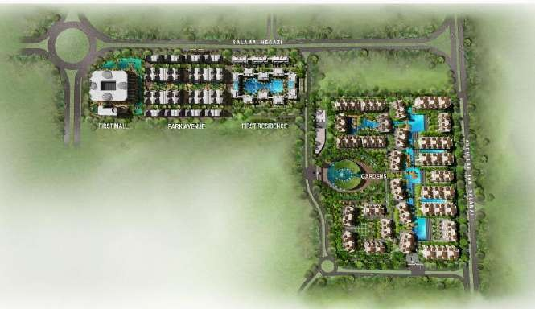
Task: Structural design, using ECP code and technical support.

“Al-Jazi Compound (Under Construction)”

Nasr City, Egypt
Block "13" consists of four plots 1, 2, 3 and 4. Each plot consists of one basement, ground and five typical floors. The structural system is reinforced concrete P.T slabs supported on concrete columns; which in turns supported on reinforced concrete isolated footings with an approximate area of 1000 m2 per each plot.
Task: Structural design using ECP code and technical support.

Helwan, Egypt
The building consists of basement, ground and first floor. The structural system of the building is a reinforced concrete flat slab with 250mm thickness supported on top of reinforced concrete columns with an area of 2450 m2.
Task: Structural design using ECP code.

Page 2 of 10

2014 – 2016
New Cairo, Egypt
Retails Shopping, Parking Areas and Entertainment,The slabs are mostly post-tensioned with spans of 16 x 16 meters.
The project consists of 8 zones; each zone divided to 3 up to 11 parts, each part with approximate area of 2500 m2. The main load bearing system consists of combinations of reinforcement concrete (RC) and post-tensioned (PT) flat slab and RC solid slabs supported by concrete beams and girders. The concrete slabs are supported on reinforced concrete columns with spans vary from 6 to 18 meters in both directions.
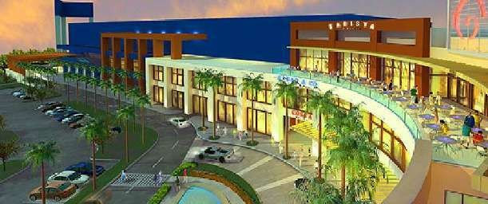
Task: check of the structural design, using ACI and ECP codes.
“Cairo Festival City Mall (To Be Constructed)

2014 – 2015

2014 – 2015

Al-Riyadh, KSA
The project constructed on 20,000 m2 and consists of two towers (North &South towers), concert hall and spa area. The main load bearing system consists of one way ribbed slabs supported by embedded or drop concrete beams. The concrete slabs are supported on reinforced concrete columns with spans vary from 6 to 11 meters in both directions
The strengthening of structural elements by using FRP techniques and steel elements techniques.
Task: Evaluate the structural aspects of the project and rehabilitation of all structural elements using ECP and ACI codes

New Cairo, Egypt
Full design for the project and technical assistance. The project consists of gymnasium and classroom buildings. The project includes two buildings; Classrooms' building consists of basement, ground floor and 2 typical floors on an area of 1000 m2.
Gymnasium building consists of basement, ground floor on an area of 1500 m2. The structural system of the classrooms is a reinforced concrete ribbed slab with varying thickness from 400 to 450 mm for most of the structure. The structural system of the gymnasium is a reinforced concrete flat slab thickness 250 mm. The slabs are supported on columns, which in turns supported on pile caps under the entire building.

Page 3 of 10

2014 – 2015

2014 – 2015

2014 – 2015

Aswan, Egypt
The project consists of ground and first floors. The structural system of the building is a reinforced concrete flat slab with 250 mm thickness and drop panels with thicknesses of 350 and 400mm on top of the reinforced concrete columns with an area of 1100 m2.
Task: Structural design using ECP code.

Dammam, KSA
The project consists of two buildings. The first is "Administration Building" which consists of a ground floor of an area of 3000 m2, first and second floors on area of 2800 m2, and a roof. The structural system of the building is a reinforced concrete flat plate with drop panels and marginal beams is adopted for the slabs. Isolated footings are used to support the concrete columns.
The second is "Ceremony hall building" consists of a ground floor on an area of 3000 m2, mezzanine with area of 1300 m2 and roof on an area of 2600 m2. The structural system of the ceremony hall is a solid slabs supported on beams is used at the mezzanine level.
Precast double Tee Pretension concrete beams are used to cover the roof. Task: Value engineering and design check using ACI code.

Cairo, Egypt
The building consists of basement, ground floor and 4 typical floors on an area of 600 m2. The structural system for the typical floors is a reinforced concrete ribbed slab with thickness equal to 450 mm. The structural system of the basement and the ground floor ceiling is paneled beam with thickness 700 mm. The slabs are supported on vertical concrete structural members, which in turns supported on pile caps under the entire building.
Task: Structural design using ECP code.

2013 – 2014
Attaba –Cairo, Egypt
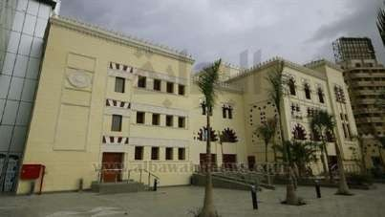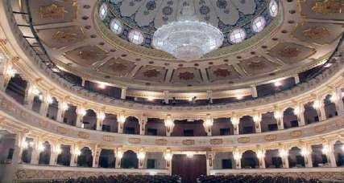Task: repairing and strengthening for the old building, structural design for the new buildings using ECP code, design of glass facade using spider systems with tension rods carried by double-box steel beams and technical assistance.
"Over-view for the theatre" "Internal-view for the theatre"

Page 4 of 10

2013 _ 2014

2013 _ 2014

Sharm El-Sheikh, Egypt
The Project constructed on 6,000m2 and consists of a palace, three villas, four swimming pools, elevated tank and parking.
Task: Structural design check design for the project, using ECP code.

The project includes two towers; tower (A) consists of basement, ground floor and 22 typical floors on an area of 1000 m2. Tower (B) consists of basement, ground floor and 21 typical floors on an area of 300 m2. The structural system of tower (A) is a reinforced concrete ribbed slab with varying thickness from 300 to 450 mm for most of the structure. The structural system of tower (B) is a reinforced concrete drop beam/solid slab flooring system with varying slab thickness from 200 to 220 mm for most of the structure. The slabs are supported on vertical concrete structural members, which in turns supported on concrete raft under the entire building. The lateral resisting structural elements consist of shear walls, cores and a series of columns.
Task: Structural design using ACI code.

2013-2014
Cairo, Egypt
Full design for the project and technical assistance. The project consists of basement, ground, first and second floors with an area of 2600 m2 each. The project also includes swimming pool and other facilities. The main load bearing system consists of post- tensioned (PT) flat slabs and RC solid slabs supported by concrete beams and girders. The concrete slabs are supported on reinforced concrete columns with spans vary from 8 to 10 meters in both directions.

2013 – 2014
Cairo, Egypt
Full design for the project and technical assistance. The project consists of ground, first and second floors with an area of 1500 m2 each. The building also includes steel structure facade.
The main load bearing system consists of reinforce solid slabs supported by concrete beams and girders. The concrete slabs are supported on reinforced concrete columns with spans vary from 4 to 7 meters in both directions.
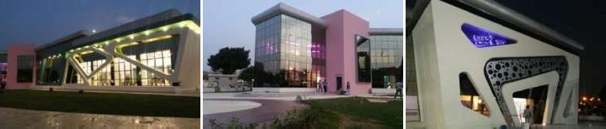
The steel facade consists of steel angles connected each others with weld connections to meet the architectural requirements.
"Air Force' Gymnasium Building (To Be Constructed)"

Page 5 of 10

2012 – 2013

2012 – 2013

Cairo, Egypt
The mall consists of three basements and ground floor with an area of 23000 m2 each, and the hotel consists of three basements, ground and 10 typical floors with an area of 2000 m2 each.
Task: Task: Value engineering and design check using ECP code.

Suez Road, Egypt
The Project constructed on 50,400m2 and consists of administrative buildings, equalization tanks, sulphonation , formulation processed buildings and clarifier tanks.
Task: Structural design check for the project, using ACI and ECP codes, and technical assistance.

2011 – 2012

2011 – 2012

2011 – 2012

6th October, Egypt
Task: Check design for the ground floor under back filling loads varies from 1.00 to 1.50m, fountains, trees and palms, rested on ground tanks and foundation of crane tower all structural check design work by using ECP code.
The ground floor area under study was 27,000 m2. The main load bearing system consists of reinforcement concrete (RC) flat slab with drop panels supported by concrete edge drop beams and girders. The concrete slabs are supported on reinforced concrete columns with spans vary from 6 to 11 m in both directions.

Cairo, Egypt
The building constructed on 4400 m2, and consists of ground, first, second and roof floor. The main load bearing system consists of reinforcement concrete (RC) flat slab and (RC) solid slabs supported by reinforced concrete drop beams. The concrete slabs are supported on reinforced concrete columns with spans vary from 3 to 9 m in both directions.
Task: Structural design using ECP code.

Cairo, Egypt
The building constructed on 8700 m2, and consists of ground, first and roof floor. The main load bearing system consists of reinforcement concrete (RC) flat slab, panelled beams and (RC) solid slabs supported by reinforced concrete drop beams. The concrete slabs are supported on reinforced concrete columns with spans vary from 3 to 9 m in both directions.
Task: Structural design using ECP code.

Page 6 of 10

2010 – 2011

2009 – 2010

2009 – 2010

2009 – 2010

Cairo, Egypt
The building constructed on 4000 m2, and consists of ground, first, second, third and roof floor. The main load bearing system consists of reinforcement concrete (RC) flat slab and (RC) solid slabs supported by reinforced concrete drop beams. The concrete slabs are supported on reinforced concrete columns with spans vary from 3 to 9 m in both directions.
Task: Structural design using ECP code.

6th October, Egypt
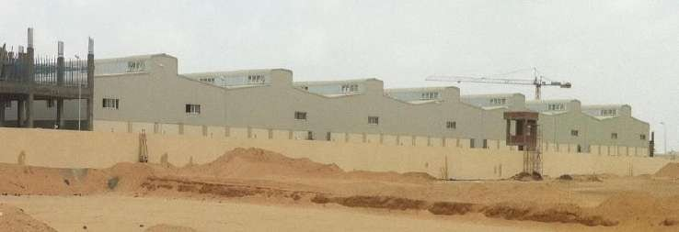
5,000 m2, made of steel structure and post-tensioned concrete buildings. Task: Structural design using ECP code.

"Metro Stores 6th October City (To Be Constructed)"

Archdiocese of the Episcopal Church (Workshop Buildings)
6th October, Egypt
The building consists of ground and three floors. The structural system is a reinforced concrete flat slab with 250mm thickness supported on top of reinforced concrete columns with an area of 1000 m2.
Task: Structural design using ECP code.

Youssef Abdel Fatah Mosque
Cairo, Egypt
The building consists of basement, ground and eight floors. The basement is a parking, from the ground to the second floor are prying zones. From the third floor to the eighth are libraries, offices, class rooms and lectures halls. The structural system of the building is a reinforced concrete flat slab with 250mm thickness supported on top of reinforced concrete columns with an area of 800 m2.
Task: Structural design using ECP code.

Page 7 of 10

Work Experience-Water Structures
2015 – 2016 Under Ground Water Tank (Cairo Festival City)
Cairo, Egypt
The water volume is 5250 m3 with a footprint of 28.5 x 46 meters. The structural system of the tank roof consists of a 500-mm reinforced concrete flat slab supported on reinforced concrete walls with thickness 500-mm. The foundation of the tank consists of a 700-mm reinforced concrete flat plate. The water height inside the tank is 4 meters.
Task: Structural design using ECP code.

2015 – 2016

2014 – 2015

2014 – 2015
Under Ground Water Tank(Ain Shams University)
Obour City, Egypt
The water volume is 850 m3 with a footprint of 19 x 15 meters. The structural system of the tank roof consists of a 300-mm reinforced concrete flat slab supported on reinforced concrete walls with thickness 300-mm. The foundation of the tank consists of a 500-mm reinforced concrete flat plate with. The water height inside the tank is 3.0 meters.
Task: Structural design using ECP code.

Rest On Soil Water Tank (TABUK, KSA)
Tabuk, KSA
The tank is composed of four compartments; each has reinforced concrete walls of 500- mm thickness and separated by expansion joints. The water volume of each part is 6000 m3 with a footprint of 31.5 x 31.5 meter. The structural system of the tank roof consists of a 250-mm reinforced concrete solid slab supported on a group of concrete beams with dimensions 600 x 550 mm, which in turns are supported on a number of square columns (600 x 600 mm) on a grid of 6.3 x 6.3 meter. The foundation of the tank consists of a 400- mm reinforced concrete flat plate with a 600 mm thickness at the edges for 2 meters width. Expansion joints are located at a maximum distance of 31.5 meters in both directions to minimize the temperature effect on the tank. The water height inside the tank is 7.0 meters.
Task: Structural design using ECP code.

Under Ground Water Tank (Carrefour)
Cairo, Egypt
The water volume is 100 m3 with a footprint of 7 x 4 meters. The structural system of the tank roof consists of a 250-mm reinforced concrete flat slab supported on reinforced concrete walls with thickness 250-mm. The foundation of the tank consists of a 400-mm reinforced concrete flat plate. The water height inside the tank is 3.5 meters.
Task: Structural design using ECP code.

Page 8 of 10

2013 – 2014

2013 – 2014

2012 – 2013

2016 – 2017
Under Ground Water Tank (Abo Rawash)
Cairo, Egypt
The water volume is 500 m3 with a footprint of 18 x 7 meters. The structural system of the tank roof consists of a 240-mm reinforced concrete flat slab supported on reinforced concrete walls with thickness 400-mm. The foundation of the tank consists of a 500-mm reinforced concrete flat plate with. The water height inside the tank is 5.0 meters.
Task: Structural design using ECP code.

Rest On Soil Water Tank (Arco)
Cairo, Egypt
The water volume is 300 m3 with a footprint of 12 x 5 meters. The structural system of the tank roof consists of a 240-mm reinforced concrete flat slab supported on reinforced concrete walls with thickness 300-mm. The foundation of the tank consists of a 500-mm reinforced concrete flat plate with. The water height inside the tank is 5.0 meters.
Task: Structural design using ECP code.

Swimming Pool (American International School in Egypt)
Cairo, Egypt
The pool has reinforced concrete walls of 250mm thickness. The footprint is 18 x 27 meters. The foundation of the pool consists of a 400mm reinforced concrete flat plate rest on piles with diameter 500 mm. The water height inside the pool varies from 1.5 to2.5 meters.
Task: Structural design using ECP code.

Underground Structures

Down Town Tunnel (Thrust Blocks, Pump, Valve Rooms)
Cairo, Egypt
The tunnel at intersection with 90th street, Cairo, Egypt. It is including pump and valves rooms. The structural system of the rooms consists of a 240-mm reinforced concrete flat slab supported on reinforced concrete walls with thickness 500-mm. The foundation of the rooms consists of a 500-mm reinforced concrete flat plate. The rooms’ depth varies from6.0 to7.0 meters.
Reinforced concrete blocks are used for supporting the pipe line at the bent points. The pipe curvatures pass through these blocks.
Task: Structural design using ECP code for the thrust blocks, pump and valves rooms.

Page 9 of 10

