Personal info Hisham
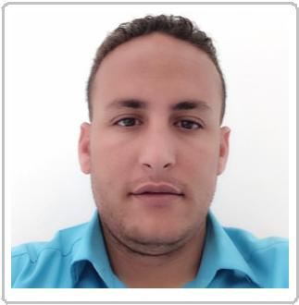

Email: hisham-394161@gulfjobseeker.com

Egyptian

09/01/1990

Accounting and Audit Plant Manager Assistant

Profile

Who Am I ?

I’m dedicated professional accountant able to perform all accounting responsibilities efficiency with more than 3 years experience in Accounting and sales field in Saudi Arabia .
My strengths include strong communication skills , accuracy , fast Learner, highly organized, detail oriented , problem solver and positive attitude.
Achieved the best package plant for grain and fodder in Saudi Arabia while I was working in the plant.
Increased plant sales with 30 % .
Increased customer numbers to 200 customer.
Seeking to work with a company to improve my skills and refresh my career path
.

Work experience

09/2014 – 03/2018 Accountant / sales representative

Jubail , Saudia Arabia

Implemented financial statements of the plant ( journal, ledger, budget) Implemented the daily reports of the incoming and outgoing stock movement of the plant .
Implemented , analyzed and send daily sales reports to the company's management .
Handled with Receivables and Payables by receiving and checking their invoices . Issued daily sales invoices to customers ( increased sales with 30 %). Implemented and analyzed the monthly and annual inventory adjustment of the plant and send it to the competent authorities .
Implemented of all accounting reports of the Receivables and the Payables of the plant.
Increased customer numbers to 200 customer.
Achieved the best package plant for grain and fodder in Saudi Arabia while I was working in the plant .

06/2012 – present General Accountant

As an Accountant I can do

Determines payroll requirements; maintains payroll data; prepares and processes monthly payrolls .
Interacts with internal and external auditors in completing audits .
Explain billing invoices and accounting policies to staff, vendors, and clients . Implement and review budgets, revenue, expenses, payroll entries, invoices, and other accounting documents .
Analyze and review budgets and expenditures for local, state, federal and private funding, review contracts, and grants .
Implement profit and loss statements and monthly closing and cost accounting reports .
Analyze revenue and expenditure trends and recommend appropriate budget levels, and ensure expenditure control .
Compile and analyze financial information to prepare entries to accounts, such as general ledger accounts, and document business transactions .
Supervise the input and handling of financial data and reports for the company's
automated financial systems .

Resolve accounting discrepancies .

Education

11/2016 – present Preparing course in PMP

Certificate Institution , Jubail , Saudia Arabia

Preparing course in professional project management ( PMP )
GPA : 92%

08/2015 – present Successful seller skills course / Digital Marketing Foundation

Online Instructor , Jubail , Saudia Arabia

GPA : 95%

09/2008 – 06/2012 General Accounting / Public Management

Sohag University , Sohag , Egypt

Bachelor of Commerce
GPA : 64 %

Skills

Language |  | Computer skills
Arabic |  | Microsoft Office 365
English |  | Internet
 |  | Quick Box
 |  | Xero
Interpersonal skills
Communication skills
Work under pressure
Highly Organized
Fast Learner
Detail Oriented
Accuracy
Problem- Solving
Work in fast paced
environment
Creative

