  - CURRICULUM VITAE

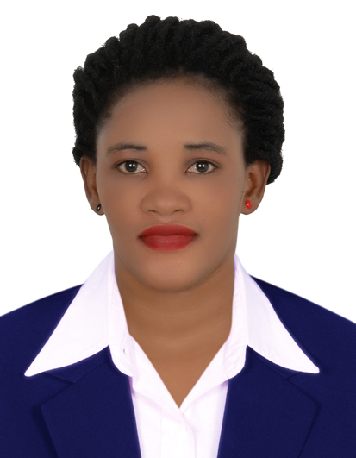
BIO-DATA
First Name : Jacquiline
Gender : Female
Marital Status : Single
Nationality :Ugandan

CONTACT ADDRESS
E-Mail : jacquiline-394162@gulfjobseeker.com

CAREER OBJECTIVES
Iam hard working, self-motivated person who can work under minimum supervision .I possess interpersonal skills, team work oriented and can succeed through hardworking under stress, and Confidentiality and integrity are my guiding principles in achieving organizational objective.
EDUCATION BACKGROUND
YEAR | INSTITUTION | AWARD
2003-2007  1995-2002 | Berkeley High School  Nakasero Primary School | Uganda Certificate of Education  Uganda Primary Education

OTHER QUALIFICATIONS

- Reliable practical knowledge on Microsoft Office package [MS Word, Excel and Access]
- Ability to work with other staff members as a team player
- Ability to work with minimum supervision
- Internet Knowledge

WORK EXPLIENCE.
Currently Working in a Food Company in UAE
As ateam member/Cashier for 2 years
DUTIES
Scan items and ensure pricing is correct.
- Greet customers and welcome them
- Take customers' orders.
- Deliver hot or food to customers.
- Take coupons and scan correctly.
- Dispense correct change.
- Take money in the form of cash, credit card

Worked in South Africa as a sales person
DUTIES
- schedule sales activity
- plan and conduct direct marketing activities
- make sales calls to new and existing client
- negotiate with client
- prepare and present sales contracts
- maintain sales activity records and prepare sales reports
- respond to sales inquiries and concerns by phone, electronically or in person
- ensure customer service satisfaction and good client relationships
follow up on sales activity
- perform quality checks on product and service delivery
- monitor and report on sales activities and follow up for management
- carry out market research and surveys
- participate in sales events
3. Worked in a Hotel as a Receptionist
Duties
- Answering or referring inquiries.
- Directs visitors by maintaining employee and department directories; giving instructions.
- Maintains security by following procedures; monitoring logbook; issuing visitor badges.

Key skills Attained
1. Good communication skills both oral and written in various languages like English an
2. Very cooperative team player and a leader with excellent interpersonal skills.
3. Good research skills both desk and field research.
4. Ability to work independently and learn from others.
5. Good time management.
6. Ability to work under a challenging environment.
7. Ability to work with people of diverse backgrounds.
LANGUAGES
LANGUAGE | SPOKEN | WRITTEN
LUGANGA(native language) | GOOD | FAIR
ENGLISH | Excellent | Fluently

HOBBIES
־ Reading novels and newspapers, magazines
־ Inter-personal communication and relationship
REFEREES

I Jacqueline hereby certify that to the best of my knowledge and belief, the information given above is correct

