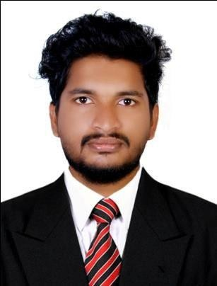

SUBIN

Email : subin-394166@2freemail.com

Location : UAE, SHARJAH

OBJECTIVE

To work with leading company and to use my analytical thinking to the best of my ability combined with perseverance, so as to contribute to organization’s growth and goal, as well as to attain my professional goal.

PROFESSIONAL QUALIFICATION:

- M.B.A. in HUMAN RESOURCE MANAGEMENT

- Pursuing CMA(USA)

ACADEMIC QUALIFICATIONS

- BA ECONOMICS (2012-2015)
- PLUS TWO (2012)
- SSLC (2010)

COMPUTER PROFICIENCY:

- HARDWARE AND MAINTANANCE
- DIPLOMA IN COMPUTARISED FINANCIAL MANAGEMENT (Ms Excel, Ms Word, Ms Power point, Tally – ERP-9, Peachtree)

. .PROFESSIONAL EXPERIENCE :
•

  - TWO YEAR EXPERIENCE IN ASSISTANT UNDER THE TAXPRACTITIONER (ACCOUNTANT)
  - FAMILLIER WITH KVAT AND GST RETURN, INCOME TAX RETUN FILLING AND ESI & PF RULES
  - CERTIFICATE FOR GOODS AND SERVICES TAX PRACTITIONER
  - ONE YEAR EXPERIENCE IN SUPER MARKET AS AN ACCOUNTANT

EXPERIENCE IN MS EXCEL, MS WORD, TALLY-ERP-9,BUSY, TAX SOFT, ACRO BIS, WINMAN

SKILLS
    - Good Communication Skills.
    - Easily negotiate with other people.
    - Have high level of persuasiveness.
    - Can work effectively in team, as well as individually.
    - Have good inter-personal skills.

Extra-Curricular Activities:

    - Played Games at college & school level.
    - Active participation in college functions as volunteer and in other Event.
    - 2nd place in Cricket Competition at College Level on 2014.

PERSONAL INFORMATION:

Marital Status: SINGLE
Sex : MALE
Date of Birth:24-05-1995
Language Known MALAYALAM, ENGLISH,HINDI, TAMIL, SANSKRIT
Nationality : INDIAN
Strength : Confident, Positive attitude, Hardworking, Punctuality, Good listener and Quick learner
Hobbies : Internet Surfing, Reading News paper, Playing Cricket, Football etc.

DECLARATION:

I hereby inform you that all the statement made above are true the best of my knowledge and belief.

( SUBIN )

