CURRICULUM VITAE
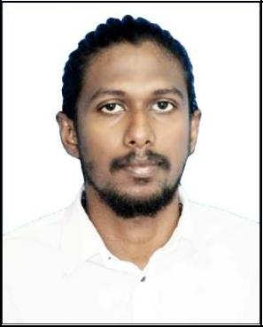

ANDRIN

Email: andrin-394202@2freemail.com

CAREEER OBJECTIVE

I am here to help People to maintain a flexible body and a stable mind set. By that I can help to build a better future for them.

EDUCATIONAL QUALIFICATIONS

- Meditation Teacher Training Course from Samagra the Center for Yoga Studies and Research in Kerala, Completed on March 2019.

- Yogasiromani (Teacher of Yoga) Studied from International Sivananda Yoga Vedanta Center in Kerala, Completed on December 2018.

- Yogacharya (Diploma in Yoga Teaching & Yoga Therapy) Studied from Samagra the Center for Yoga Studies and Research in Kerala, Completed in February 2018.

- Plus Two Higher Secondary School education from Kerala (2012).

- 10th High School education from Kerala (2010).

WORK EXPERIENCE

- 1 Years of experience as Yoga & Meditation Teacher in Kerala, India.

PERSONAL SKILLS
- Positive thinking ability & willing to take challenge

- Sincere, Confident & Hardworking

PERSONAL INFORMATION

Date of Birth

: 09-11-1994

Visa Status

: Visit Visa (Until 22-10-2019)

Nationality

: India

Languages Known

: English, Hindi, Tamil and Malayalam

DECLARATION

The above information provided is correct to the best of my knowledge and belief. I shall be grate full if you provide me the chance to work with you. I shall work to best of my abilities and you. I shall work to best of my abilities and your expectations.

Andrin

