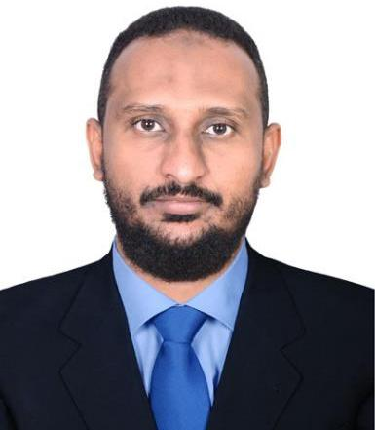
Ali

Electrical Engineer
Ali-394206@2freemail.com
Address: UAE- Dubai

Career Summary :

a competent Electrical Engineer with Progressive 14+ years of professional experience in Oil and Gas a comprehensive knowledge of maintenance and operation of Power plant generation and power systems, focusing on limiting down time, HSE, reliability, quality and sustainability. a particular Practical work experience in installation, Testing & Commissioning MV&LV, Relays, Transformers, Motors, Switch gear panels, operation & maintenance of power plant in both domestic and international(Saudi Arabia)., I have a proficient track record of project management and successful delivery maintenance programs within schedule and time constrains.

Employment Experiences:

1\ (Power Section) (Sudan):

From sep 2018 up to date.

Job description: Power Plant O&M Engineer

Responsibilities: -

- Follow all relevant safety protocols and legal codes to ensure proper operation of equipment and minimize risk of damage to property and personnel

- Keep and prepare accurate daily and monthly reports of power plant operation , (power generated, load variation, fuel consumption, lubrication oil, filters and spare parts consumption) .

- Schedule the PM & CM in service hour meter for units & equipment.
- Prepare Electrical operation procedures for equipment during normal and critical operation (blackout &

Feeder tripped).

2\ KSA):

From mar 2015 to sep2018.

Job description : Testing and Commissioning Engineer

Responsibilities: -

Page 1of 2

- Execution and supervising Erection, Testing, Pre, Commissioning of LV & MV SIEMENS&RANHIL panels, Bus ducts, motors and other electrical works as per approved drawing and specification.

- Examine installations and observe operations of the well head area (MOV, RTU, switch rack 6.6kv, lighting system) to ensure compliance with specifications codes.

- Installation of Cathodics protection (CP) transformer to protect and control the pipeline and prevent the corrosion of metal surface.
3\ Sudan):

From sep 2007 to feb 2015

Job description: Senior .Power Plant Operator

Responsibilities: -

- Monitor meters, by SCADA gauges and control boards to verify operational parameters, and make adjustments to distribution, generator output, voltage and electricity flow rates according to standard protocols and power grid requirements.

- Control a variety of power-generation equipment and machinery during normal operation, scheduled maintenance and emergency repair procedures.

- Follow all relevant safety protocols and legal codes to ensure proper operation of equipment and minimize risk of damage to property and personnel .

4\ (Sudan):

From Feb. 2005 to 2007

Job description: MDT Specialist
Responsibilities: -

- Acquire familiarity, to level needed to perform duties, with assigned business line’s range of services and products and their relationship to those of other business lines.

- Achieve functional and technical skills required for assignments.
- Picking up down hole tools (MDT)

Courses:

- Low voltage switchgears (Exemplar center) .
- Electrical power Equipment testing by (Exemplar center) .
- Modern Power System Protective Relaying (MPSPR) (Exemplar center) .
- Power generation operation & control course by Top Center for training, consultancy & quality service.

- Electro – Mechanical course from National Electricity Corporation (NEC)
- English course by Cambridge.

Education:

- 2012 B.Sc. in Electrical Engineering from Jordanian Sudanese College for Science & Technology.

Page 2of 2

  - 2004 (3 Years Diploma) of Electrical Engineering from Sudan University of Science & Technology.

- furnished upon request

Page 3of 2

