CONTACT ABDELRAZIK
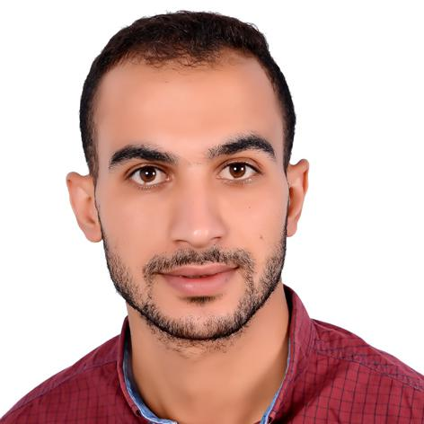

Abdelrazik-3945208@gulfjobseeker.com
Ajman, UAE

30 June. 1995, EGY

OBJECTIVE

An accountant looking for an experience seeking a challenging job in a reputable company where my skills, experience, and academic background can be implemented. Utilized and professionally developed. And help the company to advanced levels during my position.

EXPERIENCE

Aug. 2013 - May.

Pharmacy

2016

Manage financial business and payroll, Inventory Management, Accounting firms

Aug. 2016 - Aug.

supermarket

2017

Cashier

Manage financial operations with customers and ensure careful inspection Collect payments Check invoices and receipts Follow up inventory and order new products before effectiveness

Jan. 2019 - Aug.

Real Estate Investment

2019

Supervision of inventory and accounting of workers and companies. follow-up work day by day in addition to some office work and marketing of the company's business

EDUCATION

May. 2013 _ May. 2017

Faculty of Commerce Mansura University

Bachelor’s Degree in Accounting

With grade (Good)

SKILLS

Microsoft Oﬃce (word, excel)

English (very Good in speaking and typing English)

Arabic (Fluent in Arabic)

Quick learner.

Can work under pressure

Responsible and trustworthy

Can work for long time
Capable of multitasking

