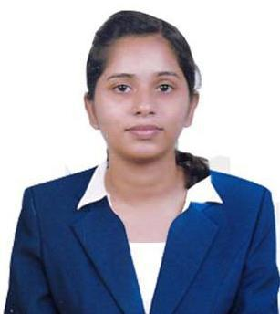
RAICHEL
ACCOUNTS ASSOCIATE (Accounts Receivable)
Email address: raichel-394214@2freemail.com
Currently in UAE on visit visa until 11 October 2019

CAREER OBJECTIVE

To pursue a career in a professional work environment to utilize my knowledge and apply my skills to grow as a responsible and efficient employee while achieving organizational goals.

EDUCATION:

BACHELOR OF COMMERCE IN FINANCE AND TAXATION
- Graduated from Mahatma Gandhi University (2014-2017)

- Graduated with a cumulative GPA of 7.95
- Actively participated in various business and management events.
- Successfully completed graduation project on “Study on effectiveness of sales promotion technique on FMCG”

MASTERS OF COMMERCE
Bharathiar University (2018-present)

Expected to complete by December 2019

CAREER HISTORY

(February 2018 - May 2019)

India
Accounts Associate (Accounts Receivable)

- Well versed with sales order creation and accounts receivable billing
- Hands on experience in project and work-breakdown structure creation, employee time bookings and corresponding amendments
- Responsible for internal reporting and dashboard preparation
- Responsible for preparation of process documentation
- Provided end to end training to new employees

SKILLS

- Proficient in SAP, Outlook, Word, Excel, Power point; Familiar with Tally erp9
- Teamwork, Innovation, Creativity
- Able to work under pressure with a calm and organized approach in order to meet deadlines
- Committed team player
- Keen listener and quick learner
- Systematic and organized
- Time Management and efficiency in multi-tasking

PERSONAL DETAILS

Date of Birth: 02 February 1996
Fluent in English, Malayalam
Marital Status: Single
Nationality: Indian
Interests: Music, Reading, Internet browsing

