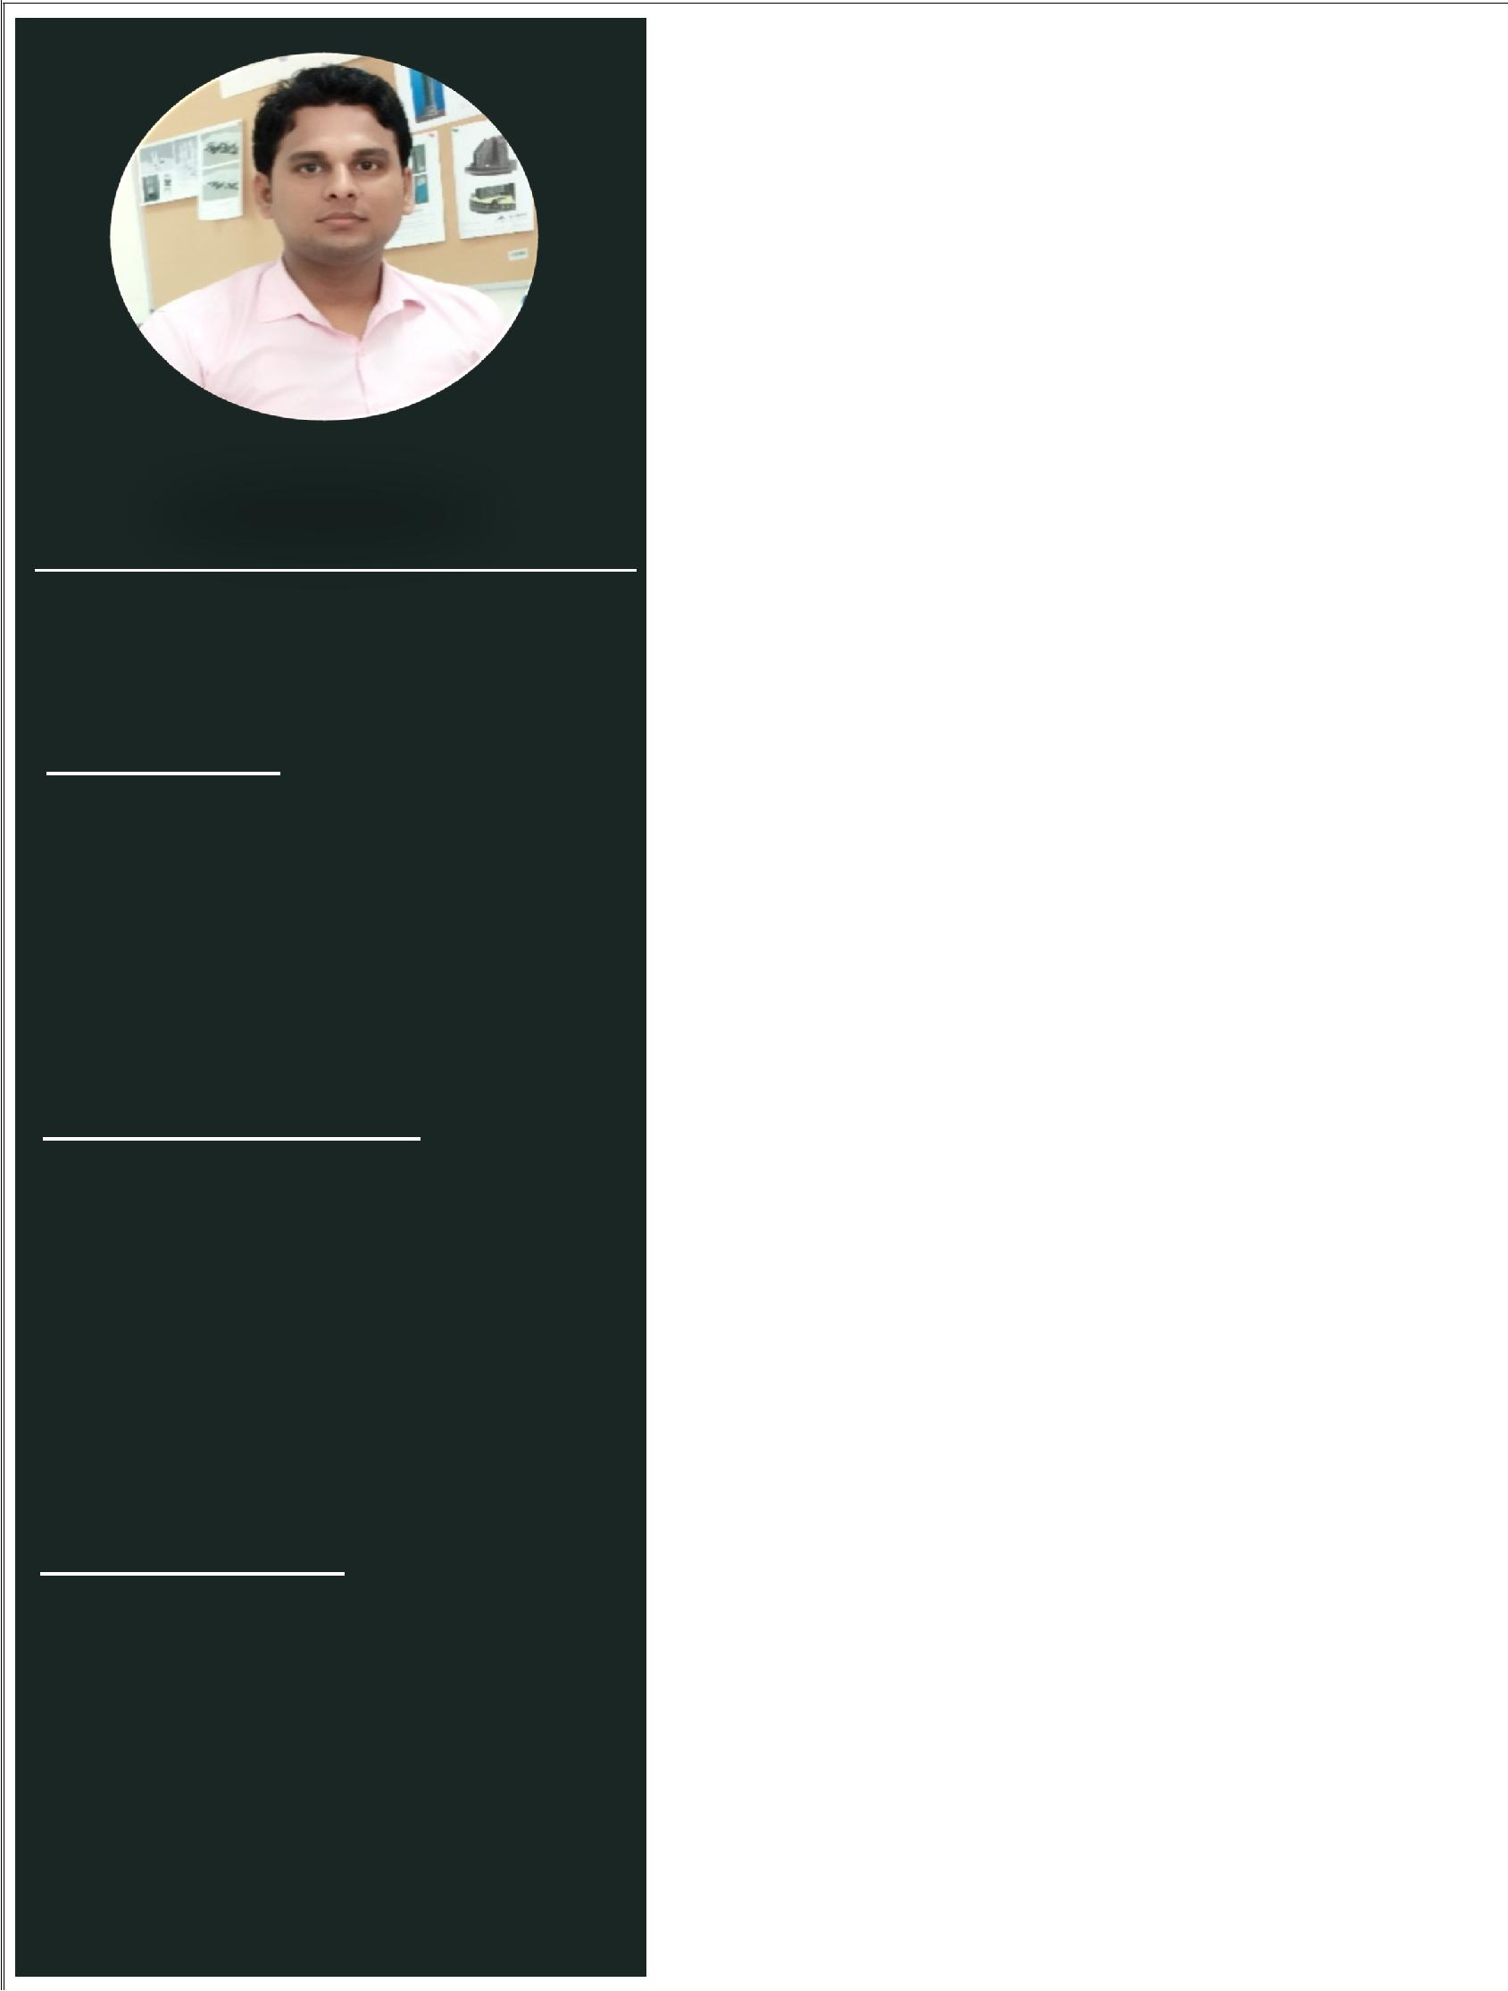

A S H W I N I

A R C H I T E C T U R A L D R A F T S M A N

O B J E C T I V E :

Aspiring for challenging assignments in a reputed organization, where my experience and skills are utilized to the utmost level and provide enough scope to explore my knowledge to serve the organization to the best of my ability and skills.

C O N T A C T D E T A I L S :

Email Id: - ashwini-394215@2freemail.com

Q U A L I F I C A T I O N

Graduation: - Bachelor of Art in Bachelor of Tourism Studies (BTS)

College: - IGNOU Delhi University

New Delhi, India

P R O F E S S I O N A L S U M M A R Y :

Architectural Draftsman with over 4-year work experience in Detailing. Well versed in using Auto CAD Any version. An Effective Communicator with good analytical, problem solving & organizational abilities.

S T R E N G T H S :

- Capable at working in a high-pressure working environment and meet tight deadlines.

- High level of commitment and hardworking, Willingness to take new responsibilities.

- Being Ability to work in an international environment,

dynamic and multicultural

R E S P O N S I B I L I T E S & A B I L I T E S :

Preparing all types of Architectural drawings by Auto CAD & RAVIT ARCHITECTURE (All Versions).

Making Architectural Shop Drawings for Residential Apartments, Duplex Villas, High-rise buildings and Commercial projects.

Making all types of Shop Drawings like Plan, Layouts, Sections & Details, Elevations, etc.

Preparing Shop Drawings for all Project items like, Block Work, Tiling (Flats & Wet Areas), RCP, Landscape, Signage etc.

Checking & Review All Sub Contractor Drawing to Ensure the Matching with IFC Drawings (Like Joinery Works, Doors, Aluminum works etc.)

Making a Section & Detailed Drawings for all Project Elements.

Distribution of approved shop drawings to the site for constructions.

Review and modifying drawing according to Consultant’s comments & follow up for consultant approval.

Making As built Drawings according to site situation.

Check all MEP Coordination & Builder Work Drawings with ability of Finding all discrepancies & Propose Solutions.

A S H W I N I |  | P R O J E C T :
A R C H I T E C T U R A L D R A F T S M A N
 | A L T A Y E R P R O J E C T A B U D H A B I
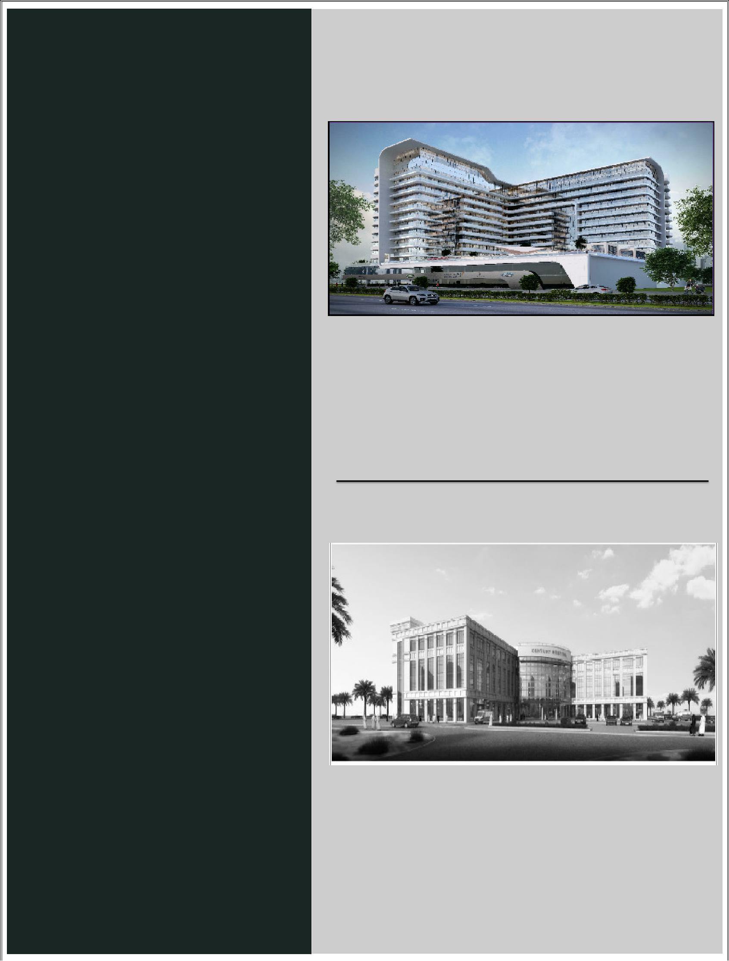

E D U C A T I O N A L C R E D E N T I A L S :

Diploma: - Diploma in Building Design

Address: - CADD Center New Delhi, India

T E C H N I C A L K N O W L E D G E :

1 Packages: - Auto CAD (All Version)

2 Packages: - Revit Architecture (All Version)

3 Packages: - MS- Word / Excel

W O R K E X P E R I E N C E :

: | CLIENT | : - AL TAYER GROUP
: | CONSALTANT | : - APG
: | VALUE OF PROJECT | : - 270 MILLION
: | DURATION OF PROJECT | : - MARCH-2017 - ONGOING

- ABOUT THE PROJECT : - MIXED USE DEVELOPMENT (Including Apartments, Car Showrooms, Swimming Pool & Landscape Area.)

T E N D E R I N G & T E C H N I C A L S U P E R V I S I O N & D E V E L O P M E N T

Designation: - Architectural Draftsman

Duration: - July 2015 to Till Date (4.1 Year)

H O B B I E S :

Playing Cricket & Listening Music

: DURATION : - MAR 2016 TO FEB 2017

: RESPONSIBELITES : - Working for Tender & Technical
Department
Team to Develop the Tendering

Submittals by Adding & Technical
Drawing & Documents.

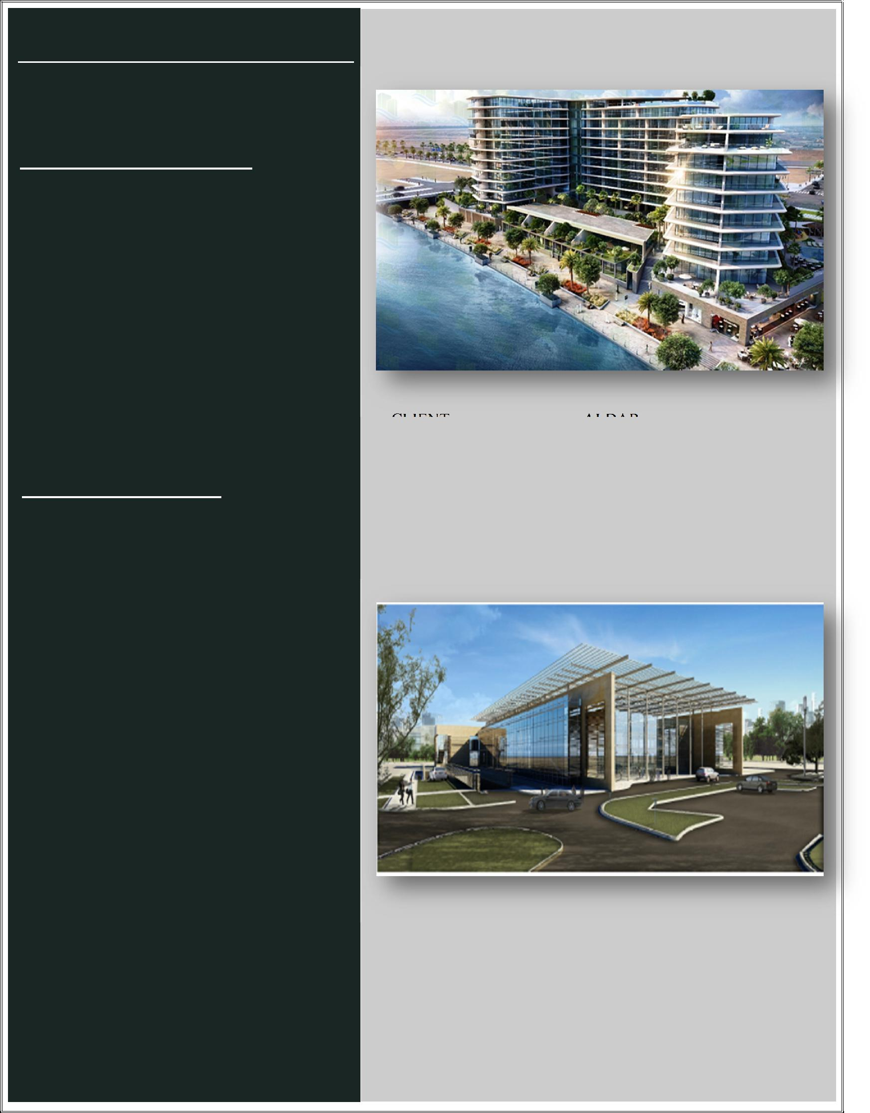
A S H W I N A L H A D E E L P R O J E C T A B U D H A B I

A R C H I T E C T U R A L D R A F T S M A N

P E R S I N A L P R O F I L E :

Date of Birth | : | 14th Nov-1990
Gender | : | Male
Marital Status | : | Married
Nationality | : | Indian
Languages Known: English, Hindi

P a s s p o r t D e t a i l s :

Date of Issue | : | 18th Feb-2015
Date of Expiry | : | 17th Feb-2025
Place of Issue | : | India

: CLIENT | : - | ALDAR
: CONSALTANT | : - | AECOM
: VALUE OF PROJECT | : - 350 MILLION

- DURATION OF PROJECT : - AUG-2015 TO DEC-2017

- ABOUT THE PROJECT: - AL HADEEL (RESIDENTAL BUILDING)

S K M C D I A L Y S I S C E N T E R A B U D H A B I

: CLIENT | : - | SEHA
: CONSALTANT | : - | LEO A DALY
: VALUE OF PROJECT | : - | 102 MILLION
: DURATION OF PROJECT | : - | DEC-2014 TO FEB-2016
: ABOUT THE PROJECT: - |  | SKMC DIALYSIS CENTER

