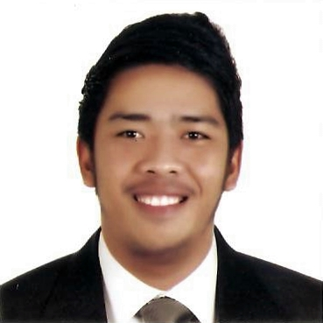
Marben
Email: marben-394218@2freemail.com

CAREER OBJECTIVES

To apply for a position that will deem fit my qualification and be of service to people with my gained knowledge and skills I have acquired in Information Technology.

PROFESSIONAL EXPERIENCE

Total experience: 1 year and 5 months (UAE experience)
Working as a Sales Staff

Total experience: 3months(Batangas City)
Working as a Product Locator(Warehouse Assistant)

Total experience: 6 months Batangas City)
Working as a Receiving and Dispatching Unit(RDU Clerk)

Total experience: 3 months (Batangas City)
Working as a Cashier

Total experience: 6 months (Batangas City)
Working as a Wholesale Checker

TRAININGS AND CERTIFICATES

On the Job Trainee
Universal Robina Corp. (600 hours)
Simlong, Batangas City, Philippines

KEY SKILLS

- Oriented in Microsoft Office programs
- Knowledge in Web Development
- Knowledge in HTML and CSS
- Knowledge in Windows OS and Ubuntu OS
- Knowledge in Visual Basic programming
- Knowledge in Adobe Photoshop
- Fast learner

ACADEMIC QUALIFICATION

School Course
Bachelor of Science in Information Technology
Batangas State University
Alangilan, Batangas City
2010 - 2014

Secondary
Batangas National High School
Rizal Avenue, Batangas City
2006 - 2010

Primary
Pallocan East Elementary School
Pallocan East, Batangas City
2000 - 2006

PERSONAL DATA

Date of Birth : August 11, 1993
Age : 26
Height : 5’4”
Weight : 72 kg
Civil Status : Single
Nationality : Filipino
Languages : Filipino/English

MARBEN

