Education

Bachelor Degree in Mechanical Engineering (BA) 2019

Al Balqa Applied University Engineering Technology College , Al Hizam Al Daeri St , Amman, Jordan

Personal Qualifications & Development

Najem
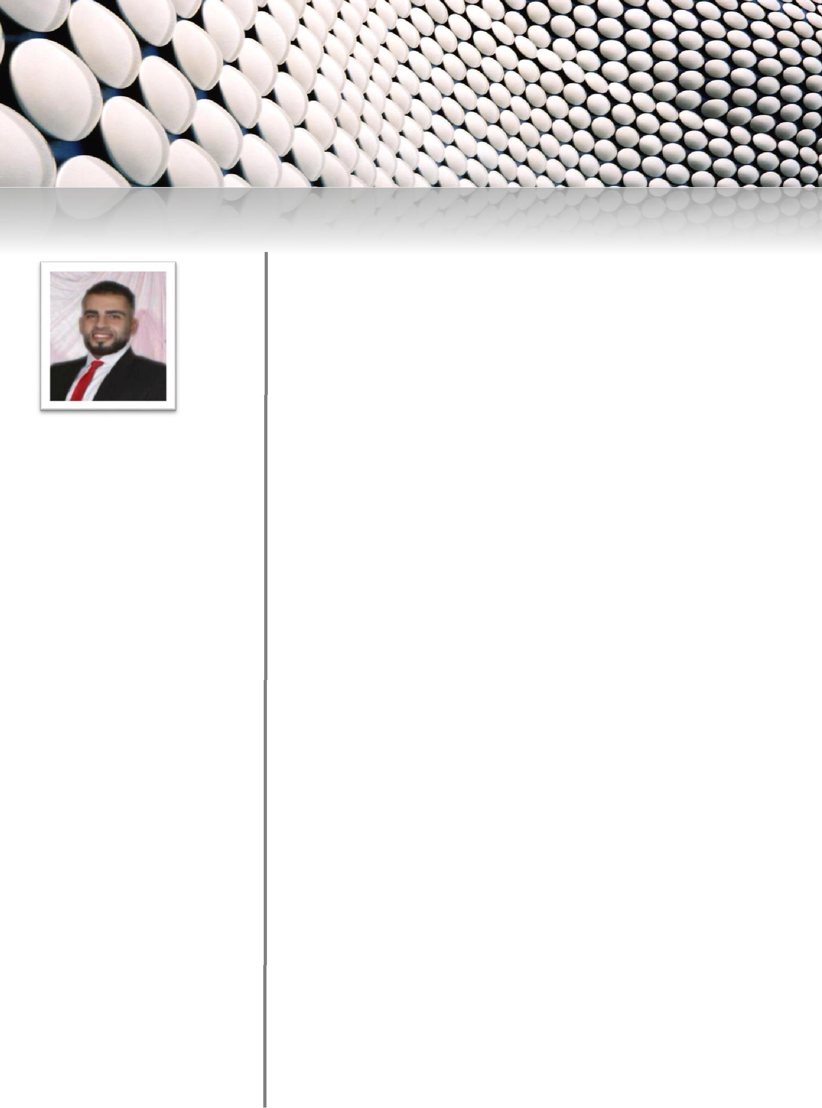
Mechanical Engineer

Email: najem-394261@2freemail.com

Career Objectives

A young ambitious Mechanical Engineer, seeking a challenging career with a progressive organization that provides an opportunity for contribution, as well as development & enhancement, of my knowledge, experience and skills, through continuous learning and teamwork collaboration.

Language Skills

English: Very Good – (speaking, Writing & Reading)

Arabic: Mother Tongue

- Expertise in the following:

    - Maintenance Engineer
    - Sales Employ
    - Painting and Decoration Practical

- skills:

  - AutoCAD
  - Pro-engineering

  - Microsoft Word, Microsoft Excel environment applications

Training Courses

Since Jan. 2019

Work Experiences

Since June 2011 until this

moment

Since Feb. 2017

Zarqa, Jordan
3 Month

- Scope of work Includes:

  - Lubrication of mechanical parts

  - Replacement of damaged pieces

-Cleaning the mechanical parts and the product line within the machine in case the machine stops for full maintenance.

Amman, Jordan

Designation: Supervisor

- Scope of work Includes:

- Pricing of apartments

-Accounting owners of apartments

- Estimate the days needed to finish the work

- Accounting workers and estimate the nature of production of the worker

- Purchase materials needed to work

- Assist and teach workers in the work of decorative facades

Amman, Jordan

- years Designation: Sales

- Scope of work Includes:

- Selling customers -Help customers

Portfolio & Preferences upon Request

