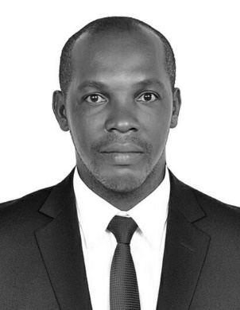 |  | EDUCATION
Federal University Of Technology Owerri, NIGERIA Bachelor of engineering (civil) 2002-2007(Building and construction engineering technology)
QA /QC 2014
UK HSE 1,2,3 CERTIFICATE 2018 NEBOSH IGC 1,2,3 UK 2019
John  CIVIL ENGINEER  Profile  Detailed Civil Engineer with more than 8 years’ experience in which more than 4 years was in Oil & Gas industry (Civil Works), John has a proven track record of finishing complex project under budget and ahead of schedule.  CONTACT  EMAIL: john-394267@2freemail.com |  | WORK EXPERIENCE

DUBAI, UAE Technical Assistant(Civil)

2018/10 -Present
Provide general support and assistant in documentation of all company inflow and outflow of materials
Assisting in fabrication and installation of Facades on site.
Assisting in designs and measurements of facade and metal works for building works
Assisting in all maintenance works on site
Assist in all safety implementation on site

Nigeria Project Manager

2016/02-2018/08Attend meetings to discuss projects with clients, contractors, asset owners and stockholders.
Prepare, track and implement project documents for approval and adherence on site.
Spearheaded multiple civil projects within NLNG plant area and resident community.
Manage project budgeted, and ensured technical requirements and milestones were met on time.

Nigeria QA/QC/HSE Supervisor

2014/02-2016/01
Attend meetings to discuss projects with clients, contractors, asset owners and stockholders.
Prepare, track and implement project documents for approval and adherence on site.
Spearheaded multiple civil projects within NLNG plant area and resident community.
Manage project budgeted, and ensured technical requirements and milestones were met on time.
Inspects the project site, implement and monitor adherence to design specifications, QA/QC and HSE policies.
Attend Project Management, Quality and HSE Training's for Supervisors for contractors.
Bid for Contracts with the assist of other technical team for the company.

Abuja, Nigeria Site Engineer

2013/03-2014/01

Supervised the earthwork and asphalt overlay on 120km road between Niger state and Kebbi State in Nigeria.

Worked with the Federal Ministry of works team to deliver the project
Work in a team with in-house Civil Managers, Engineers, designers and drafters to produce the concept, detailed design and documentation of civil projects.

NIGERIA

Part-time Lecturer

2011/03-2013/02
Developed and delievered engaging lectures to undergraduate students
Created and wrote course materials, including but not limited to syllabi,handouts,classwork and homework assignments
Planned,evaluated and revised course contents and course materials
Monitored students academic progress and recommended students who seem to be struggling to their corresponding campus resources.
A member of the invigilation teams during exam.

 |  | skillS

