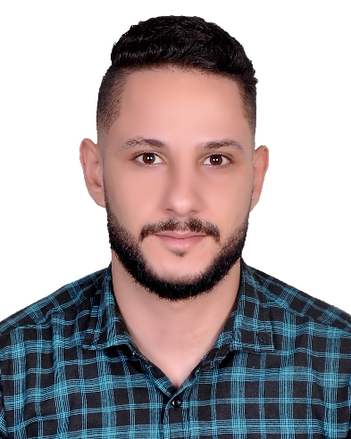
Bashar
livestock and poultry production engineer

E-mail. Bashar-394277@2freemail.com

Objectives

I plan to use my skills and knowledge inlivestock and poultry production engineering and apply them in the best way possible. I want to challenge myself by working in different departments and fields and by pushing myself beyond my limits to take on anything that is given to me. Getting the best experience that I need to help me in my career.
Qualifications:

(2010 till Sep 2014) Bachelor degree in livestock and poultry production engineering in Alazhar University, Palestine .
Experience
Job title | duties
Manager poultry farms /Palestine  October2014-Sep2015 | - Follow up all day to day farming Operations.  - Do farm records and record all needed data.  - Follow up the veterinary service and feeding operations.  - Monitor the environmental conditions (temperature, humidity, ventilation andlighting).  - Check the inventory of the feed, fresh bedding and cleaning detergents to ensure sufficient amount for daily usage.
Project assistant  October 2015- Dec 2015 | - Responsibility on 120 field workers.  - Coordination with institutions and partners in the project.  - Prepare monthly reports and send them up to the project coordinator.  - Ensuring contractors’ paperwork is completed and processed.  - Ensuring contractors safety during work.
Livestock and poultry production engineer  Jan 2016- Nov 2016 | - Follow up and management on livestock and poultry production farms.  - Veterinary service for poultry and.  - Training workshops for farmers.  - Guided tours for dairy, sheep and poultry farmers.  - Application of biosecurity on farms.
Field researcher  Palestine  Jan. 2017- July. 2017 | - Selection of project Beneficiaries {poultry and livestock farmers}.  - Filling in applications for beneficiaries selected.  - Data entry.  - Evaluate and sort applications.  - Field visit to do need assessment for selected farms.  - Do the project’s baseline and end line visits.  - Provide guidance in nutrition, veterinary health and biosecurity in farms to farmers benefiting from the project.
Veterinary assistant  }  August 2017- March. 2019 | - Selection of project Beneficiaries {poultry and livestock farmers} 2400 beneficiaries  - Filling in applications for beneficiaries selected.  - Data entry and Evaluate and sort applications.  - Do a mobile clinic and veterinary serves for all beneficiaries all the period of the project.  - Do aperiodic vaccination.  - Do surgery for sick animals if necessary.  - Following up the feeding operations followed in the beneficiaries' farms and giving them the necessary instructions  - Train farmers on occupational safety and environmental conservation measures  - Making periodic reports, conducting contracts with beneficiaries, and documentingall project’s activities,  - Responsibilityof veterinary medicines storageand documenting the Exported and imported.  - Artificial insemination in dairy cattle farms.

Skills:

- ICDL.
- Effective communication.
- Ability to work within a team efficiently.
- Ability to work under pressure.
- Ability to lead a work team.
- I like my work so I work hard.

Languages

- Arabic: Native
- English: Fluent

Personal Skills

- Always looking forward for self-development.
- Self-motivated.
- Team player.
- Aiming to deliver on time and avoid any slippage.
- Building great relations with colleagues and keeping proper communications.
- Proactive and on head of my work.
- Taking initiative whenever enhancements are possible.
- Taking ownership of tasks and making sure the work is done flawlessly.

Personal Details

Date of Birth: 07-02-1993

Address: Abu Dhabi,UAE

Sex: Male

Marital Status: Single

Nationality: Palestinian

Visa Status: Visit-Visa

Reference
- Reference will be furnished upon request

