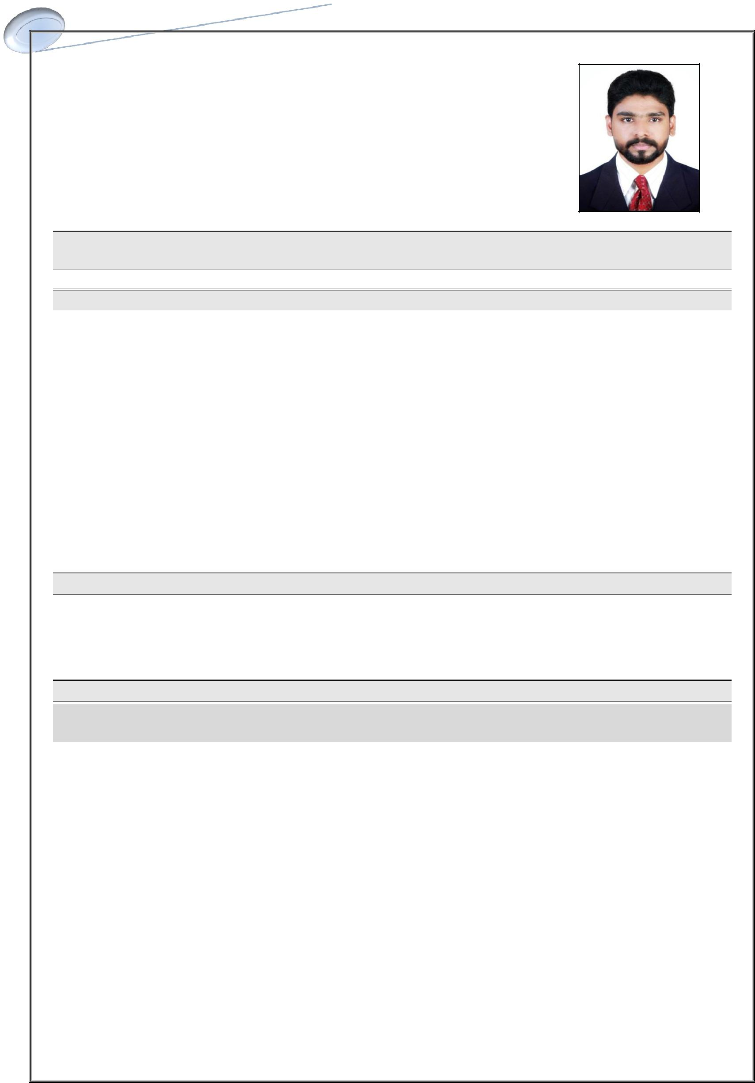
LUKMANUL

Dubai, United Arab Emirates

Email: lukmanul-394289@2freemail.com

English, Hindi, Malayalam, Tamil

Seeking Assignments as Accountant/executives in Accounts/Finance/ Inventory/Back office Department with an Organization of Repute.

Professional Synopsis

- A dynamic professional with more than 5 years of rich experience in Accounting & Inventory operations with diverse industries.

- Comprehensive experience in implementing systems, procedures & manuals for managing preparation & maintenance of statutory books of group accounts & financial statements including P&L account, Journal, Balance Sheet, Bank Reconciliation Statement ensuring conformance to time, accuracy and statutory norms.

- Skilled in managing preparation of MIS reports for providing feedback to top management for controlling performances, payables & receivables, profitability, etc.

- Possess sound knowledge of ERP Systems

- Advanced in MS Excel and proficient in Tally Erp.9, Peachtree, quick books, Gravity ERP

- An effective communicator with good relationship building and interpersonal skills.

Other Key Skills

- Operation management

- Fixed Asset Management

- Branch/ out let operations

- Receivables & Payables Mgmt - Cash mgmt.

- Liaising & Coordination - Customer service

- Inventory management

CAREER RECITAL

From July 2017 to April 2019 /// Accountant Assistant Cum inventory

Key Deliverables of Accounts

- Provides day to day Accounting operations support

- Independent handling of payment to suppliers , receivables from debtors

- Post all journal entries including closing entries, expenses allocating entries and group entries.

- Compute taxes owed, prepare tax returns report, and submit reports to senior accountant

- Preparation of payroll Report and disbursement of WPS around 15 employees

- Preparation of various reports like ageing analysis, income and expenditure statement.

LUKMANUL

Key Deliverables of Inventory

- Stocks maintaining goods receiving and preparing the GRN

- Follow up with the suppliers for the pending orders , and inform the same to the purchase in charge

- If the stock is not available in stores then immediately inform and suggest the substitutes

- Follow up with the suppliers for the tax credit note of the returned item & undelivered products and inform to the purchase in charge

- Removing the expired or damaged items from the floors and from the system.

- Participating in the yearly and half yearly stock taking in the floor and other locations.

- Maintain proper file of the purchase invoices with the GRN & LPO for the record.

- Assisting the Purchase in charge and floor managers to prepare the monthly reports

From Sept ’2015 to Jan ’2017. /// Accountant cum admin assistant

Key Deliverables

- Generating and finalizing various Books of Accounts and Reports associated with Payables, Receivables as well as Cash management. Coordinating with all departments on behalf of Management

- Follow-up and Monitoring Collection and Allocation of Payments, Customer account details for Nonpayment, delayed payments and other irregularities.

- Responsibilities of all record keeping aspects of Accounts Payable, such as Payment due dates & amounts. Prepare and keep AP Registers, Monthly Reports for Management. (Tally ERP V 9, MS EXCEL). Including MIS Reports and BRS

- Exposure in dealing with suppliers for their various credit periods and debt collection from the customers those has credit facilities.

Notable Highlights

May ’2013 – Aug ’2015 /// Assistant Accountant

- Involved in the generation and finalization of various Books of Accounts, Stock Inventories and Taxation reports for various Clients. (Manual & Tally 7.2)

- Rendered assistance to the Senior Accounts Officer for the generation of various Books of Accounts and other Financial statements

- Rendered assistance towards typing, filing, preparation & finalization of Books of Accounts (Cash Book, Purchase Ledgers, Sales Ledgers, Journal and Stock inventories).

- Involved in the generation of Manufacturing, Trading, Profit & Loss Account and Balance Sheet for various firms and provided assistance the Auditor for Auditing the Books of accounts of various clients. (Manual &Tally 7.2)

- Verification of Banks Reconciliation Statements, Fixed Assets and Stock verification

- Filing and return of K vat and and making online transactions

- Preparation of monthly banking reconciliation statements

LUKMANUL

ACADEMIA

Bachelor of commerce /// 2011 -> 2013

Higher secondary education /// 2009-> 2010

COMPUTER SKILLS

TALLY ERP 9, PEECHTREE, QUICK BOOKS, GRAVITY, ACRO-BIS

MS EXCEL, MS WORD, MS POWERPOINT, ADOBE PHOTOSHOP

PERSONAL DOSSIER

Date of birth

: 06/11/1992 – Age 26

Passport Details

: M7079297

Issued Date

: 06/03/2015

Expiry Date

: 05/03/2025

Place of issue

: Malappuram

Visa status

: Employment Visa

I hereby confirm that the information furnished above is true to the best of my knowledge.

Thank you

LUKMANUL

