PROFILE

Ambitious Electrical Engineer, who continuously exceeds both company and personal goals. Having 4+ Years of Experience in the field of EPC Project and Industrial automation.

Deira, Dubai

Ijas-394320@2freemail.com

Indian

KSA & INDIAN Driving License

Single

26 years old

IJAS
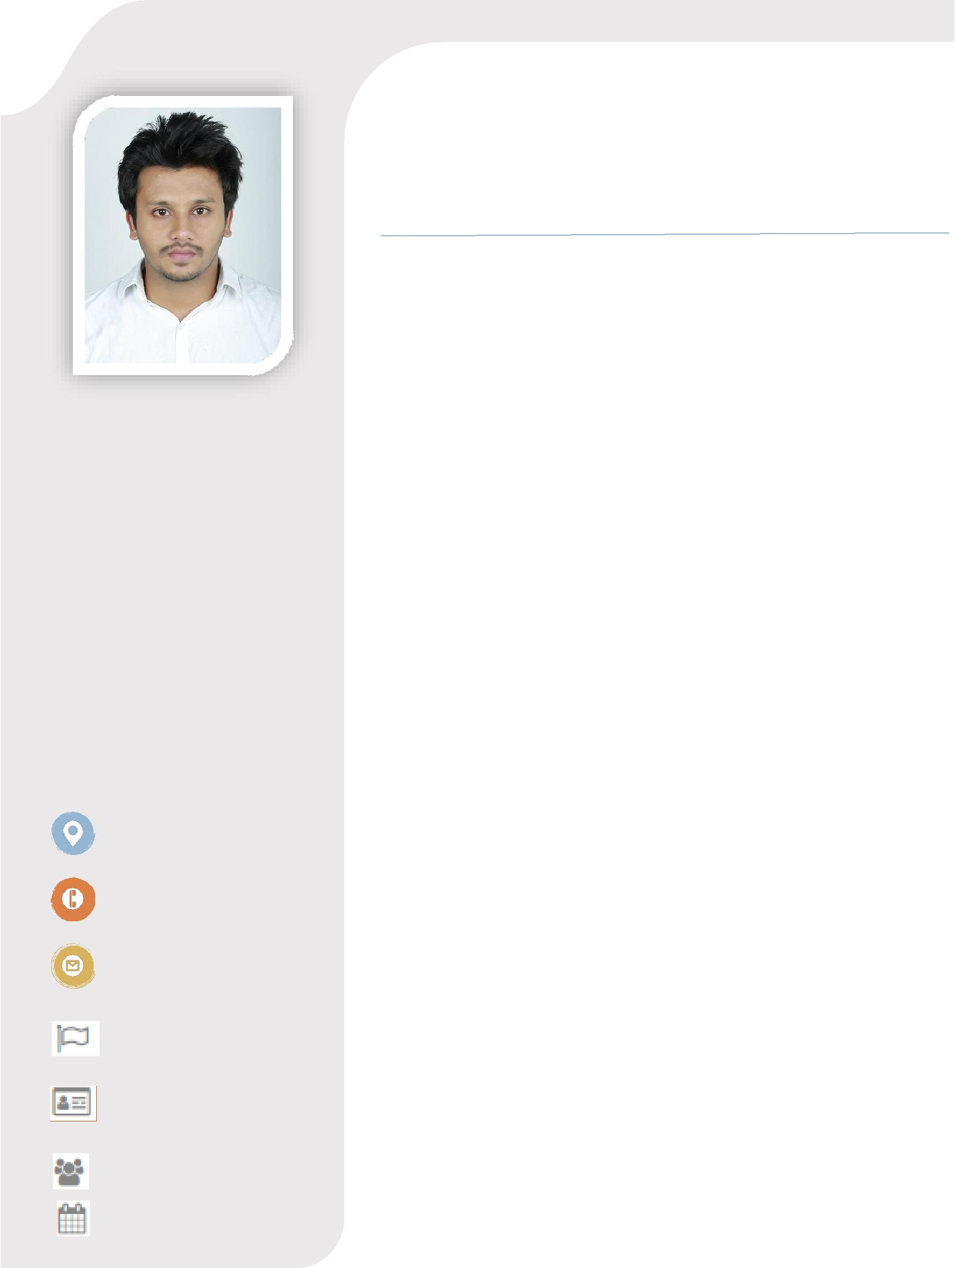

ELECTRICAL AND ELECTRONICS ENGINEER

- EDUCATION

INDUSTRIAL AUTOMATION / WARTENS TECHNOLOGIES Bangalore

December 2018

PLC, HMI, SCADA, VFD

MEP Electrical / AGHORA Design Academy Kerala

From July 2014 to September 2014

Auto CAD 2014 (Autodesk Certified Professional)

Bachelor of Technology in Electrical and Electronics Engineering

- University of Calicut Kerala From July 2010 to June 2014

Bachelor of Technology (Electrical and Electronics Engineering)

from MEA Engineering College, (Calicut University)

Perinthalmanna, Kerala in 2014 with 6.5 CPGA (First Class)

- WORK EXPERIENCE

Electrical and Instrumentation Engineer / Jeddah, Saudi Arabia

From June 2017 to May 2019

Hands on experience in water desalination plant construction, testing and commissioning (6,000 cubic meter per day capacity) as well as maintenance (40,000 cubic meter per day capacity).

Furthermore, detailed list of my expertise as an electrical engineer are listed below;

AS PROJECT SITE ENGINEER

- As project site engineer, review electrical drawings and refer issues requiring changes, assign job tasks and work as per project schedules, inspect work quality and progress.

SKILLS

- Industrial automation

PLC, HMI, SCADA, VFD.

Control system architecture.

Selection of material.

Configuration and

troubleshooting.

- Desalination

Familiar with RO plant processes, construction, testing and commissioning.

Knowledge in construction safety.

Best building

practices.

- Project Management

Methodical approach to problem solving.

Open to new ideas and procedures.

Approaching challenges with confidence.

Subcontractor management.

Project

scheduling.

- Electrical design

Single line diagram.

Power and control circuit design.

Load scheduling.

- Installation, testing and commissioning of 250kVA Generator, 15kW UPS, Automatic transfer switch and distribution power panels.

- Installation testing and commissioning of magnetic flow transmitters, flow switch, pressure transmitters, temperature transmitter, ultrasonic and hydrostatic level transmitter, conductivity/chlorine/pH analyzers and other related instruments of desalination plant.

- Installation of PLC panel, Remote I/O panels, profibus and profinet network.

- No load and load test for various motors, and VFD parameter settings.

- Underground cable laying, jointing, termination and testing of power cables.

- Meggar test, loop test and continuity tests for cables.

- Installation of earthing and lightning arrester system. Earth resistance test and continuity test for earthing network.

- Inspect the work quality and attend for inspection requests.

- Review and approve progress payment certificates of contractors.

- Installation, testing and commissioning of firefighting system, fire alarm system and FM 200 system.

AS MAINTENANCE ENGINEER

- As a maintenance engineer, keeps equipment operating by following operating instructions, troubleshooting breakdowns, maintaining supplies, performing preventive maintenance, necessary repairs, etc.

- Experience in working with Allen Bradley VFD (Powerflex 7000 and 750 series), Soft starters (Schneider), Motors (up to 900kW), Air compressor (Atlas Copco), Motor management relay (GE 469), Fire alarm system and other common electrical equipment.

- Plan, coordinate, and monitor plant corrective and

preventive maintenance of the Plant and its equipment including new installations if any required

- Inspect on a routine base of electrical equipment, wiring, fixtures and other components to ensure they remain functional

- Determine the reasons for any malfunctions of systems or components, and create a maintenance or repair plan to solve the problem

COMPUTER SKILLS

- AutoCAD

- Simatic manager o WinCC

o TIA Portal o MS Oﬃce

LANGUAGES

- MALAYALAM o ENGLISH

o HINDI o ARABIC

HOBBIES

- Football

o Chess

o Travelling

- Ensure adherence to the applicable maintenance procedures, permit to work, and safety standards including PPE compliance

Electrical design and automation Engineer / Bangalore, India

From April 2015 to March 2017

- Design, installation, testing and commissioning of essential automation products of Siemens PLC, HMI, CNC, Drives etc and designing the control panel.

- Design and implement PLC and HMI applications using Simatic manager, WinCC, TIA Portal.

- Design and implement electrical system, products, components and circuit using AutoCAD.

- Conduct factory acceptance test of PLC and HMI applications, skid instruments and control panels.

- Make part list of electrical materials and provide related engineering information.

- Diagnose malfunctioning systems, apparatus, and components, using test equipment and hand tools, to locate the cause of a breakdown and correct the problem.

- Program installation and commissioning of the machine at customer places.

- DECLARATION

I hereby declare that the above information is correct and true to the best of my knowledge and belief.

Place: Dubai

Date : 08/26/2019

