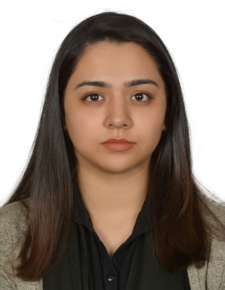
Sameen
Email: sameen-394323@gulfjobseeker.com

Career Objective:
Be placed in a challenging and rewarding job, which will help me to meet the aims and objectives of the concerned organization to enhance my knowledge and develop my career.
Personal details:
Name: Sameen
Date of Birth: 14/09/1994
Nationality: Pakistan
Gender: Female
Language: English/Urdu/ Arabic
Driving License: Automatic
Education:
- O Levels in 2013 from St.Mary’s Catholic high school, UAE. (GCSE board)
- Currently enrolled in Westford School of Management, UAE for Bachelor’s in Business Management.
Experience:
- Travel Consultant
- Sales Associate/Cashiering for Garage; Apparel Group.
- Cashiering & Waitressing at a café.
- Sales Associate
Skills:
- Proficient with the use of Windows MS Office, PowerPoint Presentation and internet.
- Excellent communication skills.
- Able to multi-task and work under pressure.
- Fast Learner/Team Player
- Dealing with customers on a daily basis. Indoor/Outdoor sales.
- Proficient with operating electronic cash registers and processing payment.

