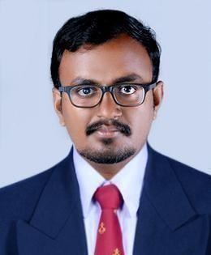

ROBY

Email id : roby-394329@2freemail.com

CAREER OBJECTIVE

Always work ahead of the company’s expectation, and prove myself to be one of its valuable assets. Seeking a suitable and challenging permanent position with a well-known and professionally managed organization, where I can apply my skills and talents.

EDUCATIONAL QUALIFICATION

Qualification |  | Institution and |  | Year of | Percentage
 |  | Board/University |  | Passing

Post-Graduation |  | June 2019
Diploma in | SMEC Labs |  | 85%
Industrial
Automation
B.E-Electronics | JJ College of |  | 7.186(CGPA)
And |  | April -2016
Communication | Engineering and
Engineering | Technology,
 | Tamilnadu
 | St. Marys H .S.S, | March -2011 | 71 %
Higher Secondary
 | Kottarakra
SSLC | St. Marys H .S.S, | March-2009 | 82%
 | Kottarakra

INDUSTRIAL AUTOMATION TRAINING ATTENDED

- PLC(Allen-Bradley ,ABB ,SIEMENS,DELTA ,OMRON,SCHNEIDERELECTRIC,GE-FANUC) 

- SCADA(IFIX ,CITECT ,WinCC ,FACTORY TALK VIEW,WONDERWARE) 

- VARIABLE FREQUENCY DRIVE 

- PNEUMATICS AND FIELD INSTRUMENTS 

- HMI 

- SCHNEIDER PAC 

- MOTOR CONTROL CENTRE PANEL 

- INDUSTRIAL SAFETY 

SOFTWARE SKILLS
 CITECT |  | WPL Soft
 RS Logix |  | Factory Talk View
 Ms Word |  | WinCC
 Ms Excel |  | CX Programmer
 Logic Pro |  | I fix
 Simatic Manager |  | MS Outlook

Work Experience
(2016-2017)

*Medical coding projects

- Online class coordinator *trainee for AAPC certification

GENERAL SKILLS

- Excellent Communication and Presentation Skills

- Highly Motivated and Target Oriented

- Very much adaptable and flexible

- Team player with ability to lead and initiate

- Creativity

- Trouble shooting

PERSONAL SKILLS
o | Writing
o | Travelling
o | Dancing
o | Photography

PERSONAL DETAILS
Passport Details
Date of issue | : | 29/01/2018
Date of expiry | : | 28/01/2028
Languages known | : English, Malayalam, Hindi, Tamil
Date of Birth | : | 18/06/1993
Sex | : | Male
Nationality | : | Indian
Marital status | : | Un-married

DECLARATION

I hereby declare that all the statements made in this resume are true, complete and correct to the best of my knowledge and belief.

Place : Sharjah

Date : Roby

