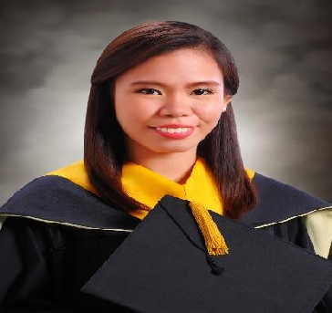

Leizel
Email: leizel-394355@2freemail.com
QUALIFICATIONS

- Analyze, examine and interpret account records, compile financial information, and reconciled reports and financial data.
- Process journal entries and perform accounting corrections to ensure accurate records.
- Self-organize, initiator, independent worker, ability to multi task and prioritize.
- Team worker, but works independently when necessary.
EDUCATIONAL BACKGROUND

Tertiary Education: University of San Carlos
Address: P. Del Rosario St., Cebu City
Degree Program: Bachelor of Science in Accountancy Year Graduated: 2011-2016

Secondary Education: Salaman Institute
Address: Brgy. Aurelio Freries Sr., Lebak, Sultan Kudarat Year Graduated: 2007-2011

Elementary Education: Salaman Central Elementary School
Address: Pob. I, Lebak, Sultan Kudarat Year Graduated: 2001-2007

SKILLS

- Knowledgeable in Oracle, Microsoft Office and Indinero Software
- Sound knowledge of Accounting Concepts
- Possess strong analytical and problem solving skills
- Skilled in presentation and preparation of financial statements

AWARDS AND RECOGNITIONS

Certified Tax Technician
July 2019

Certified Financial Advisor
April 2018

Certified Public Accountant
October 2016
- Cum Laude Accountancy Department University of San Carlos
- Consistent Dean’s List Accountancy Department University of San Carlos

Certified Bookkeeper
Bookkeeping NCIII May 2013
- Class Valedictorian Salaman Institute Batch 2011
- Class First Honorable Mention Salaman Central Elementary School Batch 2006

3rd place in Metrobank-MTAP-DepED Math Challenge

SEMINARS AND TRAININGS ATTENDED

- SEC and BOA updates
Waterfront Hotel 2018

A Seminar on Financial Management and Taxation and a Forum with Board of Accountancy
University of San Carlos 2018

Take Charge of your Future Making You Financially Capable
Waterfront Hotel 2018

Deutsche Bank: Introduction to Investment Banking
Gansenwinkel Hall University of San Carlos 2015

USC Accounting Convention: Leap & Beat The Odds: Capturing the accounting Vision, Gearing Towards ASEAN Integration
Convention Hall- SM City Cebu 2014

Banko Sentral ng Pilipinas: Symposium on Currency
University Of San Carlos 2012

Business and Finance Convention Activity Center
J.Y. Square Mall 2012

ORGANIZATIONAL AFFILIATIONS

- Philippine Association of Certified Tax Technician
- Philippine Institute of Certified Public Accountant
- National Federation- Junior Philippine Institute of Accountants
- JFINEX- Member
- Dance Talent Circle -Member
- Assistant Editor-in-chief –Pioneer School Paper

WORK EXPERIENCES

- Accounting Associate
June 2018 – August 2019

- Financial Advisor
April 2018 – August 2019

- Accounting Analyst
March 2017- June 2018

- Accounting Intern
March 2014 - May 2014

- Audit Assistant Intern
October 2013 - February 2014

VOLUNTEER EXPERIENCE

- Proctor/Room Watcher for Professional Regulation Commission Examination
- Assisted in the 69th PICPA annual National Convention

