Sarina

Email | : | Sarina-394368@2freemail.com
Place | : | Dubai, UAE
Position | : | Food and Beverage Professional

PROFILE:

A highly resourceful, flexible and enthusiastic associate with experience of maintaining high standards of service.

OBJECTIVE:

Currently looking for a suitable position with an organization, that offers excellent opportunities for development and career progression.

WORK EXPERIENCE:

- Downtown Dubai

Present serving for one of leading 5*Hospitality service in Dubai, since May/2017 to till date as a F&B Service Captain, for All Day Dining Multi Cuisine Restaurant.
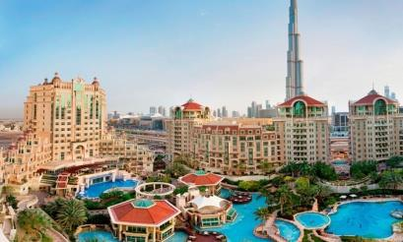

Working as part of a team that includes mangers, hostesses and bar tenders. Responsible for welcoming guests to the restaurant and promoting the food and beverage menu list.

DUTIES & RESPONSIBILITIES:

  - Delivering outstanding food and beverage service to customers.
  - Greeting all guests, using the guests’ name as often as possible.
  - Taking orders from guests and offering advice on the menu.

  - Giving guests an accurate bill then taking payment from them in cash or credit cards.

  - Ensuring the Cashier Tally Sheets are accurate, and any discrepancies are noted and Signed by a supervisor.

- Adhering to all Licensing Laws and Weights and Measure Acts.

- Keeping the Place of Work and surrounding area clean and always organized.
- Escorting customers to their tables.
- Removing dishes and glasses from tables and taking them to kitchen for cleaning.
- Preparing accurate checks that itemize and total meal costs and sales taxes.

- Dubai

February 2012 – April 2017

F&B Service Captain
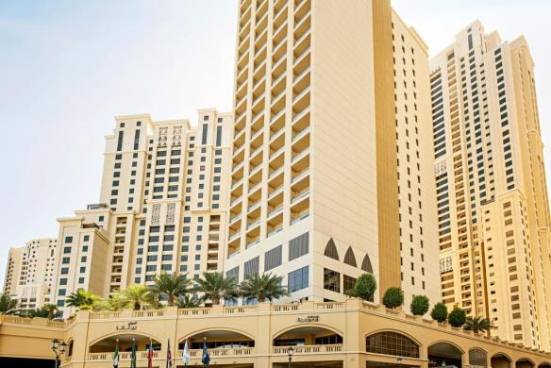

- Meet the clients.

- Introducing the company products and facilities.
- Bringing their attention by doing trails.
- Deliver beverages and food in a timely manner.

- Follow up events and updating the event calendar.
- Creating ongoing promotion activities.
- Developing business by group sales and cooperative events.
- Work with other servers and be a team player.

ACHIEVEMENTS:

Achieve “Employ of the month” in the year of 2016 in Amwaj Rotana Jumeriah Beach Dubai, UAE.

PERSONAL SKILLS:

- Able to work under pressure and meet deadlines.
- Confident and hard working.

- Positive thinking, willingness to learn.

TRAINING PROFILE:

- Lobby Hostess in Front Office
03 Months training completed in Amwaj Rotana Hotel (Dubai)

PROFESSIONAL QUALIFICATION:

- BHM&CT 3rdyrs from Silver Mountain School of Hotel Management.

TECHNICAL SKILLS:

- Basic knowledge of Computers, MS Office, Internet browsing & Mailing.
- Document Controller at IBM software from January 2011- January 2012

PERSONAL PROFILE:

- UAE Driving Licence-3 (Exp: 13/07/2026)

- Marital Status: Single
- Nationality: Nepali
- Hobbies: Listen music & Interacting with People
- Languages known: English, Hindi, & Nepali
- Date of Birth: 16-10-1991

DECLARATION:

I hereby declare that above mentioned information is true to the best of my knowledge and belief.

Applicant

Sarina

