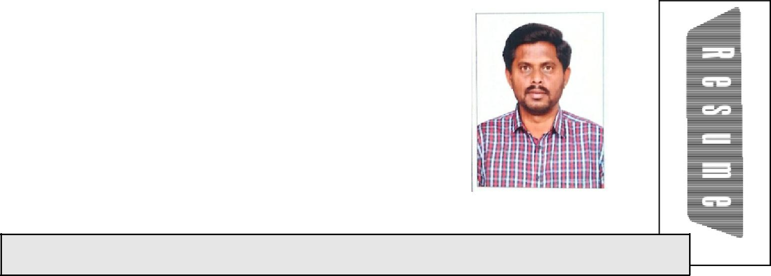
VELLIANGIRI

.

Email: velliangiri-394404@2freemail.com

Availability:Immediatejoining

_{P}ROFESSIONAL_{O}BJECTIVES

Amotivatedindividual,lookingforcareergrowthincivil&structuralindustries. Competent,diligent&resultorientedconstructionmanagementprofessional offeringover10yearsofworkexperienceinmanaging,directingandmonitoring bothHighrisebuildingsandsmalscalecivilengineeringprojects.Enthusiastic, reliableandcompetentwithagoodeyefordetail,possessingtheabilityto operateuponowninitiativeorasaresourcefulteammember.Experienceof workinginvariousprojectswithdifferentpeoplehastaughtthevalueoftactand diplomacyaswelasadegreeofassertiveness.Conscientiousandableto maintainaconsistentlyhighstandardofwork,eventotightdeadlines.Result orientedprofessionalwithmeetingthedeadlinesforcompletingtheprojectin time.

AnEnthusiasticpersondesiringforaskiledjobwhichinvolvestheemphasisof technicalaspectsacquiredthroughmyknowledge.

_{R}OLES_{&R}ESPONSIBILITIES

- Expertiseinconstructionmanagement&siteconstructionactivities.

- ResponsibleExpertiseinconstructionmanagement&siteconstruction

activities.

- Responsible forworking closely with the end clienton various construction and civilengineering projects,creating detailed plans, monitoring/updatingprogress,criticalpathanalysis,earnedvalueanalysis, etc.

- Ensure consistencyofmaterialrequirements and procure required civil/structuralmaterialsasperquantitysurveyed.

- Identifyscopeofwork,findoutprojectspecification&methodologyto suitablyalocateworktoconcernteammembersandsub-contractors.

- Proficientinmanaging&coordinatingworkwithotherdisciplinessuchas

1

process,electrical&mechanicaltoachievetime&costtargets.

- Prepare projectdocuments such as shop drawing,weekly/monthly progressreport,methodofstatement,inspectiontestplan,requestfor inspection (RFI​s),job safetyanalysis,QA/QC testreports & sub-contractorsbils.

- Superviseandinspectcivil,structural,andarchitecturalworksatworksite

toensurecompliancewithapprovedprocedures,drawingandproject

specifications.

_{E}XPERIENCE_{R}ECORD

Position : SeniorEngineer ​(Jun2018​-July2019)
Project :​Construction​ofmultistoreybuildings
Chennai

Position : Sr.ProjectEngineer​(Nov2013​-May2018)

Project :​ConstructionofMultistoreyBuildings,SewagetreatmentplantBuildings

&CommunicationTowerprojects

(EPCMainContractor)

Location :​​Qatar.

Position :SiteIncharge​(june2012-Nov2013)

Project :​ConstructionofWarehousesatECRRoad,Chennai

(ResidentialBuilding)​

​ Chennai

Position :​SiteIncharge ​(sep2009-June2012)
Project :​Construction​ofHighRiseBuildings
Chennai

Position :SiteEngineer​(Dec2005-April2009)

Project :​ConstructionofCommercialBuildings

Salem

Position :Sitesupervisor​(April2003-Nov2005)

Project :​ConstructionofHospitalbuildingandIndividualHouses
Erode

2

_{S}TRENGTHS_{&A}REAOF_{E}XPERTISE

Haveexperiencedinskildemandingjobsindesigningandexecutionof architecturalstructures.Specializedin

- EngineeringProcurementConstruction(​EPC​)projects,

- SewageTreatmentPlant

- LargescaleResidential&commercialbuildings

- Publicsectorbuildings

- Privateresidentialdevelopments

- SiteInspections&Execution

- ProjectCo–ordination

- PlanningSchedule Preparation

- Biling(Client&SubContractor)

- SafetyAspects

_{P}ERSONAL_{S}KILLS

- TimeManagement

- RiskManagement

- Technicalskils

- learningskils

- CommunicationProjectCreativity

- CriticalThinking

_{A}CADEMICS

Degree :BachelorofCivilEngineering(Part-time)-(2005–2009)

Colege :GovernmentColegeofEngineering,Salem–636011.

University :AnnaUniversity,Tamilnadu.

Percentage :70.00%

Discipline :DiplomainCivilEngineering-(2000-2003)

Colege :GovernmentPolytechniccolege,Coimbatore University :StateBoardofTechnicalEducation,Tamilnadu.

Percentage :76.00%

3

_{C}OMPUTER_{P}ROFICIENCY

● Modeling&Drafting - AutoCADD,ArchiCADD

- Documentation&Planning - MsOffice,MSProject

_{P}ERSONAL_{D}ETAILS

DateofBirth :02.11.1985

LanguageProficiency :English,Tamil,Hindi

MartialStatus​ :Maried

VisaType :VisitVisa

VisaExpdate :13/11/2019

Date : WithRegards,

Place:UAE

(P.Veliangiri)

4

