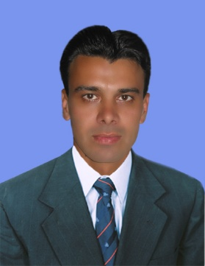
Curriculum Vitae

ATTA

E-Mail: atta-394417@2freemail.com

SUMMARY

- Having Good Communication Skills.
- Adaptable and persuasive.
- Ability to work in difficult conditions.

OBJECTIVE

- To take up the challenges of life by way of learning and experiencing to achieve highest degree of self-satisfaction and therein serve the organization and society by developing oneself.

PERSONAL INFORMATION
- Date of Birth: 15/04/1980
- Domicile: Swabi (KPK)
- Nationality: Pakistani
- Religion: Islam
- Marital Status: Married
- Visa Status: Employment (Free Zone)
- Driving License: . LTV No. 3 (Manual)
Expiry Date: 22-05-2021.

EDUCATIONAL QUALIFICATION

S.S.C BISE Peshawar 2nd Division
F.A BISE Peshawar 2nd Division
B.A University of Peshawar 2nd Division
B.P.ED University of Karachi. 2nd Division
M.Sc in Physical Education Gomal University D.I.Khan 1st Division

WORKING EXPERIENCE

- Worked as a Physical Education/sports Teacher i
- Worked as Sports Teacher from 24th September 2007 till 7th Feb,2018
- 11 months experience as a sports teacher in Kernal Sher Killi.
- Performed duty as a Judge in Sports Complex Islam Abad.
- Performed duty as Director of Physical Education from 15/04/02006 to 26/09/2006.
A C H I E V E M E N T S

  - Award and Certificate from Mr. Azam Khan Hoti as a Camp Organizer and sports Organizer in IDP’s Camp Mardan on 22nd April 2010.
  - Award and shield from Tahir Imran president of Pakistan open climbing competition Islam Abad on 10th December 2012.
  - Appreciation Certificate from Mardan Board for good Organizer and Referee (Inter colligate Volley Ball Champion Ship Girls and Boys.
  - Appreciation letter from The City School Mardan for getting good Positions of my students in Northern Regional Athletics Meet in Sports Complex Islam Abad on 12th March 2010.
  - Appreciation letter from The City School Mardan in Annual exhibition in March 2009 for a clay model of ancient Olympics.
  - Appreciation letter from The City School Mardan Campus for organizing successful basketball tournament in October 2008.
  - Appreciation letter from The City School Mardan Campus for organizing successful foot ball tournament in November 2008.
  - Have been a player of Karachi University Hockey Team in 2004 and 2005.
  - Appreciation letter from The City School Mardan Campus for organizing Inter School Basket Ball Tournament in December 2010.

COMPUTER SKILLS
- MS Office Automation,
- Windows, operating system etc.
- Internet Browsing

LANGUAGES

Fluent in:
- English
- Urdu
- Pushto
- Hindi

