Experience
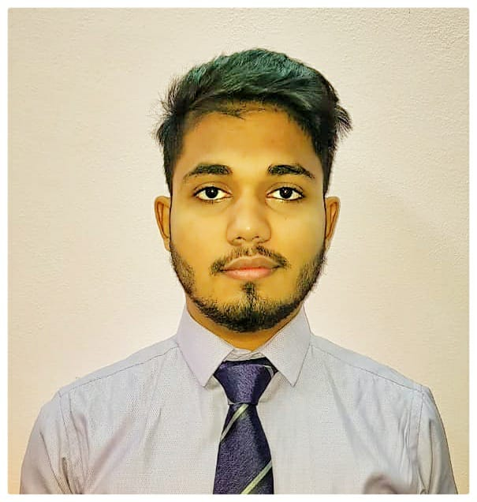

UBAIDULLAH
  - electronics and instrumentation engineer

Objective
Seeking a job position in a reputed engineering firm in order to build a long-term career endowing the best of my technical knowledge and to serve organization with an outstanding output.
I have high degree of initiative, have ability to communicate & grasp new concept quickly. Further I believe that my analytical skills would positively contribute to your organization.
An opportunity to be in challenging environment to utilize and enhance my capabilities. Ready to take any opening and challenge in automation field.
With my credentials, I am confident of offering significant value addition services to your organization

Skills & Abilities
- Automation designing and programming of PLC’s
- HMI, VFD
- Script writing in SCADA
- Creating graphical representation on SCADA
- IoT based industrial automation
- MATLAB, Simulink

2015-2019
Designing of automation project and configuration of PLC based automation project at MJCET.
Enhanced my capability in programming of PLC while working on project in programming of PLC (Allen Bradley) and configuration with real time output.
PLCs can range from small modular devices with tens of inputs and outputs (I/O), in a housing integral with the processor, to large rack-mounted modular devices sorting the defective peace with a count of thousands of I/O, and which are often networked to other PLC systems.
Proved academics and curricular achievements and possess right skills to propel the organization in achieving goals and objectives.

Education

muffakham jah collage of engineering and technology, osmania university

B.E, (2015-2019)
COURSE WORK: power plant instrumentation, instrument calibration, electrical machines, power electronics, integrated circuits, transducer and measurement, control systems.

sri chaitAniya junior kalasala, board of intermidiate education

(2013-2015)

course work: maths, physics, chemistry.

all saints high school, S.s.c

2013

COMMUNICATION
- Excellent written and verbal communication skills
- Confident, articulate, and professional speaking abilities (and experience in my project seminar)
- Empathic listener and persuasive speaker
- Speaking in public, to groups, or via electronic media
- Excellent presentation and negotiation skills

LEADERSHIP
- Possess strong commitment to team environment dynamics with the ability to contribute expertise and follow leadership directives at appropriate times
- Thrive in a team environment and work well with others
- Enjoy working as a team member as well as independently
- Team leader and team player

Vitals
KARAMA DUBAI, UAE
E: ubaidullah-384418@2freemail.com

