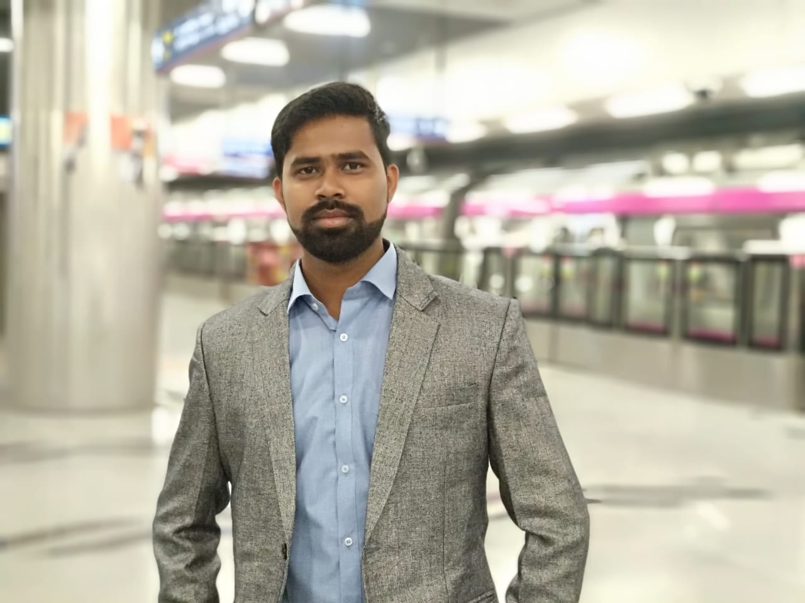
ANKU
Email address: anku-394428@datachampion.com

OBJECTIVE:

To pursue a challenging & career oriented position in the field of Travel Industry which offers immense opportunity based on skills, professional expertise, target achievements and cope to the challenges through dedication and commitment.

WORK EXPERIENCE:
5 Years of Professional Experience
Travel Company: (March 18 to Present)
Sr. Travel Counsellor
Gurugram, India,
Duties & Responsibilities
- Corporate Travel booking and Ticketing( Void/ Exchange)
- Corporate Quality Analysis( Issuance/Exchange)
- Find Lower Fare by GDS( Saber and Amadeus)
- MCO and EMD issuance.
- Refund by GDS
(September 2017 to March 2018)
BSP/ARC Executive
Gurugram, India.
Duties & Responsibilities
- Commission update by ARC and BSP.
- MCO and Ticket void by ARC and BSP.
- Daily report sent to Client.
- Weekly Profit/ Loss report sent to Manager.
- Weekly call with Client.

(September 2015 to August 2017)
BSP Ticketing Executive
Gurugram, India.
Duties & Responsibilities
- Ticket issue and Exchange by GDS( Amadeus/ Saber/ Galileo/World span)
- RTW Ticketing ( Round The World)
- Manual, Cat, IATA, Group Booking and ITX Ticketing.
- Payment by BSP
- Ticket Refund by GDS.

(February 2014 to July 2015)
Ticketing Executive
New Delhi, India.
Duties & Responsibilities
- PNR Creation, Fare Pricing by GDS( Amadeus)
- Invoice
- Call with Passenger
- Daily report sent to Manager.

GDS Skills:
- Amadeus.
- Galileo.
- Saber.
- World span.
- Apollo.

Specialized Skill:
- Find the lowest fare them void or reissue the TKT.
- Global Routing with Global Indicators, IATA worldwide Geography, Journey Types, and Carrier Specific fare, One Country Rules.
- Visa (US, Schengen visa, OK to Board, Visa on Arrival.
- Outlook: Very much familiar to use outlook.
- MS Office – Advance Excel and World.
- Tally.

EDUCATIONAL BACKGROUND:
IATA (Foundation in Travel Tourism with Amadeus)
New Delhi.
India.
May 2016- September 2016
P.S college Madhepura.
I.com
March 2011-July2013
Manohar Durga High School.
10th
March 2009 to 2013

Relevant Qualifications:
Languages:
- English: Fluent in speaking and writing
- Hindi : Mother language

PERSONAL INFORMATION:
Nationality :India
Marital Status :Married
Date of Birth :July 14, 1995

References:
will be provided on demand

