RESUME
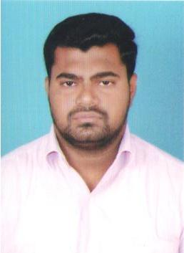
AHAMED
Email: ahamed-394429@2freemail.com
Visa Status :Visit visa 3 months from 26/09/2019
CAREER OBJECTIVE :

To work in a challenging environment where my knowledge contributes to innovation and the growth of the company by exhibiting my technical excellence along with my good communication and analytical skills.
EDUCATIONAL QUALIFICATION:

Course | College | Percentage of  Marks | Year of passing
B.C.A | Syed Hameedha Arts & Science  College,Kilakarai | 64.121% | 2004 to 2007
H.S.C | Syed Ammal Higher Secondary  School,Ramanathapuram | 75% | 2002 to 2003
SSLC | Islamiah High School,Kilakarai | 85% | 2001 to 2002

EXTRA QUALIFICATION :
- MS-Office excellent in MS-word &MS-Excel
- Diploma in Computer Application

PROJECT :
- Blood Bank(Oracle)

SPORTS :
- Volley Ball
- Cricket

Key Skills :
For Cashier
- To handle all cash payment vouchers.
- To collect cash from above 800 drivers an daily basis.
- Reimburse all staff payment bills.
- Maintain all bank transfer such as, cash transfer, cheque posting, and cheque transfer.
For Stores Management
- Distribute check salary to the staff as advised by management.
- Maintaining the stock of material without any variance by conducting stock verification and documentation.
- Implementing Standard Operating Procedures within the warehouse.
- Regularizing material receipts and ensuring the fluidity of stocks from warehouse to stores.
- Marketing all cash receipts at cash voucher submit to management on daily basis.
For accounts and audit

- processing high value invoices/critical vendors
- Validating and processing freight invoices

GULF EXPERIENCE :

- Worked as a Cashier in Sharjah from 2008 to 2011
- Worked As a Stores keeper in Fujairah from 2011 to 2013
(Enclosed with Visa copy)

PERSONAL DETAILS :

Date of Birth : 27/05/1986
Age : 33 years and 3 months
Gender : Male
Marital Status : Married
Nationality : Indian
Religion : Muslim
Languages known : Tamil, English and Hindi
Declaration :
I hereby declare that all the statements made in the above curriculum vitae are correct to the best of my knowledge and belief.
Place: Signature,
Date: (AHAMED)

