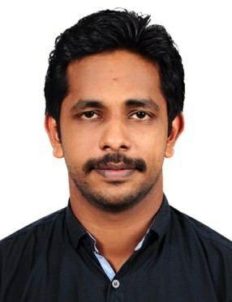
OBJECTIVE

Justin
justin-394431@2freemail.com

Highly qualified and extensively trained professional with 5 years of experience. Now looking to obtain a full
-time position in leading company that provides an opportunity to apply my acquired skills for the advancement of the company.

PROFESSIONAL EXPERIENCE

Designation : Assistant Engineer

Work Experience : September 2017 to present

Designation : QC Engineer
Duration : May 2014 to May 2017

PROFESSIONALSUMMARY

- Monitor power plant equipment and indicators to detect evidence of operating problems.
- Start or stop generators, auxiliary pumping equipment, or other power plant equipment when necessary.
- Control or maintain auxiliary equipment, such as pumps, fans, compressors, condensers, feed water pumps, filters, to supply water, fuel, lubricants, air, or auxiliary power.
- Record and compile operational data by completing and maintaining forms, logs, or reports.
- Solution design involves formulating customized products to meet the application need.

- Being in a manufacturing company, have worked closely with design and development team to tailor solutions for potential customers and strengthening the basics of motion technology.

- Technical knowledge helps the customer to get quick clarification before heading towards technical team.

- Has successfully delivered numerous presentations introducing products as well as company profile at various client sites and exhibitions.

- Initiated numerous email and telephonic discussions as well as on-calls with customer and end user.

- Testing, Validation, Customer complaint analysis.

Co-ordinate client relationship,sales force,document and contact management as well as administrate enterprise-wide reporting.
- Generate and submit weekly project status and progress report to senior level management to support business directives.

- Took lead role in stall designing for Automation, 2014 and 2016 Exhibition, Mumbai.

ROLES AND RESPONSIBILTIES

- Prepared and submitted product test status and defect reports.

- Problem Solving, Electronic prototype testing and Quality checking, Presentation Skills, General Programming Skills, Technical Understanding, Verbal Communication, Requirements Analysis and innovation.

- Experience in Testing and Trouble shooting of Motor drives, Medical Prototypes etc

- Coordinate and investigate with Customers for repeated failures along with Development Design teams.

- Involve in product design to guarantee adherence of coverage for meeting end user requirements.

- Co-ordinate client relationship, sales force-documentation, application as well as R&D projects for OEMs.

- Solving client problems and helping in the design of custom-made products. Orchestrate conferences, onsite customer visits to access and implement product and service enhancement.

- Experienced in providing pre-sales technical assistance and product education of motion solutions.

- Onsite visits regarding providing solutions to OEMs. Responsible and accountable for the coordinated management of multiple related projects directed toward strategic business and other organizational objectives.

ACADEMIC QUALIFICATIONS
Course & year | Institution | Percentage
B.TechElectronics&Communication (2009-13) | COLLEGE OF ENGINEERING POONJAR  -CUSAT UNIVERSITY | 60
HSC (2007-09) | ST.ANTONY’S HSS – POONJAR | 74
SSLC (2007) | ST.ANTONY’S HSS – POONJAR | 81
PERSONAL PROFILE

Date of Birth : 19th January 1992
Nationality : Indian
Sex : Male
Marital Status : Single

Languages Known : English, Malayalam, Hindi and Tamil DECLARATION
I hereby declare that the above provided information is true to the best of my knowledge and belief. Place: Cochin

Justin

