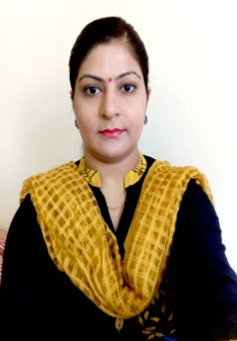
RUPINDER
Dubai (UAE)
Email: rupinder-394433@2freemail.com

PROFILE SUMMARY

Looking for an oppurtunity to secure the position of a computer teacher in a reputed organisation where i can employ all my skills, knowledge and work experience for personal as well as organisational growth.

WORK EXPERIENCE
Computer Teacher in PUNJAB, INDIA (from May, 2013 to June, 2015)
Core competencies:
- Conducting classes, labs and all computer related activities for students of grades 7th to 9th.
- Integrated technology in classroom such as Smartboards and audiovisual aids to supplement learning process.
- Planned the lessons and outlined the course objectives in line with the school curriculum.
- Monitored students progress by conducting regular class tests, recording the results and issuing reports.
- Guiding the students in computer project- related presentations for various inter-school competitions.
- Coordinated with other class teachers and staff members to learn new techniques in staff training sessions.

Qualification
B.Sc (Computer Science)- 2005-2008: Passed with 70.33% marks from KMV college , Jalandhar affiliated to Guru Nanak Dev University(Amritsar)
M.Sc(Computer Science)-2010-2012 : Passed in Honours with 70.5% marks from HMV college, Jalandhar affiliated to Guru Nanak Dev University(Amritsar)

Personal Detail
Marital Status: Married
Gender: Female Date of Birth: 7 November 1986
Nationality: Indian
Age: 32 Passport Expiry Date: 28-02-2029
Language: English, Hindi, Punjabi Visa Status: Visit Visa
Skills &Abilities
- IT Skills: Microsoft Office, HTML, SQL , Java 2.0 , C++, ASP.net, Internet applications.
- In-depth knowledge of the subjects taught.
- Hardworking ,passionate and cooperative with peers.
- Always willing to learn from available sources inorder to improve my skills and knowledge.
- Good communication and interpersonal skills. Good command over English language that makes on-the-job procedures easier.

Conclusion & Declaration
I hereby declare that the above mentioned infomation is true & correct according to the best of my knowledge & experience.

(RUPINDER)

