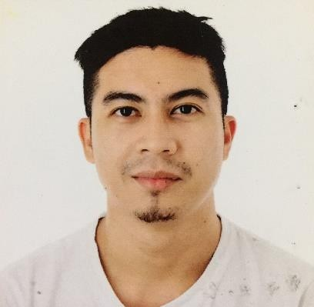
Manuel
Email Add.: manuel-394444@2freemail.com

Objective: Dedicated and highly motivated individual desirous of working as a Computer
Technician, possess high degree of readiness to respond and resolve computer system problems and furnish technical assistance with good knowledge of LAN and WAN, in addition to exceptional research and analytical abilities.
Employment Summary

Sharjah, UAE
March 2013 – present Acting Shift Supervisor

Duties and Responsibilities
- Receiving delivery items from the suppliers.
- Monitoring the expiration of the items.
- Gives answer to the customer’s question or concerns related to the product and demonstrate good knowledge of the product.
- Deal’s with the customer complaints professionally and with restrain.
- Setting goals for performance and deadlines in ways that comply with company’s plans and vision
- Organizing workflow and ensuring that employees understand their duties or delegated tasks
- Monitoring employee productivity and providing constructive feedback and coaching

Alabang, Muntinlupa Metro Manila, Philippines June 2011 – 2013
Senior Computer Technician

Duties and Responsibilities
- Installing software or hardware.
- Maintaining and repairing equipment.
- Troubleshooting different computer issues.
- Determining and installing appropriate security measures.
- Configuring computer networks.
- Providing technical support on-site or via phone or email.

Competency Skills

- Installing hardware and software system.
- Maintain and repair technological equipment (e.g. routers) or peripheral devices.
- Install well-functioning LAN/WAN and other networks and manage components (servers, IPs etc.)
- Perform regular upgrades to ensure systems remain updated.
- Troubleshoot system failures or bugs and provide solutions to restore functionality.
- Keep records of repairs and fixes for future reference.
- Offer timely technical support and teach users how to utilize computers correctly.
- Data recovery, Networking, installation and virus removal.
Educational Background

Tertiary
Bachelor of Science in Information Technology Pamantasan ng Lungsod ng Muntinlupa
2008-2012
Personal Information

Gender : Male
Age : 28 yrs. Old
Date of Birth : Sep. 03, 1991
Religion : Muslim
Place of Birth : Philippines
Marital Status : Married

I hereby to certify that the above information is true and correct to the best of my knowledge.

Manuel

