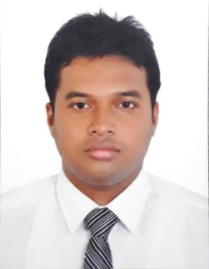­

Roy

Resume



* Credit card sales for Emirates Islamic Bank,
* Generate lead with market visit and reference.

Sales officer/ Dubai

* Attained store walk-in customer, solving customer quarry and making sales from service with memorized entire line of company products & services, including prices and special discounts
* Provided full service regarding billing, discount, monthly or daily statement with fast customer satisfaction & resolving issues at 95% rate.
* Remained courteous and calm, even during moments of customer dissatisfaction
* Maintained store stock in monthly basis

2014 - 2018

CUSTOMER CARE EXECUTIVE/ *Kolkata, India*

2018 - 2019

* Handle customer service team and installation team with duties including signing up new customers, retrieving customer data, presenting relevant product information, and cancelling services
* Trained two new team in how to use CRM, entering customer data and organizing customer interaction logs
* Received an average 87% customer satisfaction rating to date, 7% higher than company average

URBAN JIO POINT MANAGER/ Kolkata

2016 - Present

Professional experience

B.A.   
*Calcutta University*

*Kolkata, India  
2014*

Team Leadership

Problem Solving

Excellent Communication Skills

Microsoft Office

SKILLS

EDUCATION

Customer Service Representative with almost 5 years of experience in telecom customer service, including sales, tech support, and customer care. Familiar with major customer service software, conflict resolution, and possess a positive attitude. Aiming to use my proven skills to effectively fill the role in your company.

[Roy-394455@2freemail.com](mailto:Roy-394455@2freemail.com)

Contact

About me