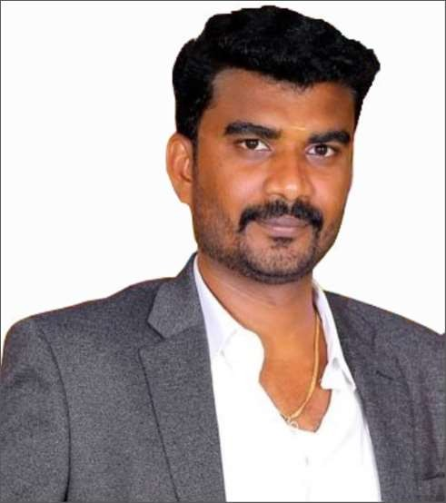
- An accomplished professional with consistent success of over 9 years in achieving sustained revenue and profitability growth in operations
- Currently working as a Facility Engineer – MEP in Dubai in leading teams for daily operations for business worth AED 3 million in revenues per annum, driving operations, coordination's and reporting for all UAE Perform ongoing preventive maintenance and repair work on facility mechanical, electrical and other installed systems
- Maintain, operate all HVAC systems and associated equipment, electrical equipment, plumbing systems, building management system and building repairs
- Perform facility inspections and report on condition affecting operations
- Monitor and supervise HVAC preventive maintenance contracts
- Respond to emergencies
- Prepare and submit summary reports of conditions in building and recommended actions to be taken
- Review and understand equipment and methods of operations, BMS system, fire / life safety and other systems
- Comply with all safety procedures and requirements
- Maintain compliance to city, country, state ordinance and codes
- Support any afterhours building needs and activities as required
- Attend training sessions and seminars
- Other assigned tasks as requested
Key Skills
Analytical and problem solving
Team Working
Team building and
leadership
P&L Management
Profit center operations
ERP, MAXIMO and CADD
operations
VASANTH
OPERATIONAL PROFESSIONAL – FACILITY ENGINEER – FACILITY MANAGEMENT
- B.E (EEE) from Anna University, Chennai with expertise in Electrical and Electronics Engineering
- Knowledge of engineering principles, maintenance of facilities, planning and undertaking scheduled maintenance
Managing budgets Analytical and problem-solving skills Energy efficiency & cost effectiveness

Vasanth-394466@2freemail.com

Career Timeline
Maintenance Supervisor
in Dubai
Facility Engineer
Since Sept ‘15
June ‘09 – May ‘15

Education
B.E (Electrical and Electronics Engineering
from Anna university, Chennai in 2009
Soft Skills

Communicator
Innovative
Thinker
Collaborative
Intuitive

Work Experience Sep ’15 till date

June ‘09 – May ‘15
in Dubai as Facility Engineer – MEP
Full P&L and operational responsibility of the team. Overseeing 70 employees and 4 direct reports spanning across various locations in Dubai.

Significant Achievement:
- Customer Satisfaction: Respond to every workorder with a customer satisfaction survey. Allow ratings on a scale of 1-5 and ask for comments.
- Reactive versus proactive work: The data analysis constraints the time utilized by technician for reactive work and proactive work and implement more proactive work
- Life cycle cost: Maintaining data about total cost included for maintaining an asset including labor, parts and contractor cost and analyzing with that to similar equipment or comparable facilities to improve performance
- Energy Savings: Suggesting the clients to change the daily usage electrical lamps to LED to reduce the electricity consumption by 30%
- Work schedule compliance: Monitor the technicians’ tasks as promised the customer on time and divide the jobs completed by jobs promised.

as a Maintenance Supervisor.
Drove operations and ensured continuous production, focused on proactive maintenance, maintaining live production lines without any operational failures and created reports on daily services

Significant Achievement:
- Successfully maintaining production of ceramic tiles on various production lines without operational difficulties and try to reduce the failure cost
- Reducing the maintenance cost for each asset by preparing proper schedules for preventive maintenance and for daily inspection reports
- Preparing reports on monthly basis for every production line equipment’s life cycle cost for a monthly review meeting to enhance the production by repairing or replacing the old equipment’s

